IMPROVING QUALITY OF SOLAR COOLING SYSTEM WITH TRIZ

P.R. Apte, T.I.F.R., Colaba, Mumbai,
M.L. Amrute, H.J. Kadakia, D.M.C.O.E., Airoli, Navi Mumbai,
S. Deshpande, Neil Automation Technology Ltd., Pune

Abstract: Harnessing solar energy as an alternate energy resource is an attractive proposition. Solar energy conversion to cool farm produce is an important and relevant application for the rural areas in a vast tropical country like India. A solar cooling system, based on adsorptive refrigeration principle and having main components as ‘solar panel’, ‘zeolite’, ‘condenser’, ‘container’ and ‘evaporator’, has several contradictory requirements between two or more performance criteria. The aim of this paper is to improve the component and system functions using TRIZ (a Russian acronym for Theory of Inventive Problem Solving) methodology. The paper also describes how “TechOptimizerTM”, a software package based on TRIZ methodology, is used to create quality in an engineering systems or product.

1. INTRODUCTION :

(a) Solar Cooling System:

Solar energy is a plentiful renewable natural resource. Harnessing it as an alternate energy resource will supplement existing energy resources without creating any hazardous environmental side effects. Solar energy conversion to cool farm produce is an important and relevant application for the rural areas in a vast tropical country like India. Further, it would not depend on availability of electricity, would be cheap and maintenance free. A solar cooling system, based on adsorptive refrigeration principle^{[1]}, has main components as ‘solar panel’, ‘zeolite’, ‘condenser’, ‘container’ and ‘evaporator’, which are interconnected as shown in Figure.1.

We could identify several difficult problems particularly connected with efficient heat transfer between components of the solar cooling system. Several of these problems are connected with contradictory requirements between two performance criteria. It is also apparent that solutions to these do not lie in the refrigeration engineering practices. Such problems are termed as ‘Inventive Problems’. TRIZ is a Russian acronym for Theory of Inventive Problem Solving and consists of a set of tools to help solve the problems mentioned above. The aim of this paper is to improve and optimize the components individually and overall system function using TRIZ methodology and software tools based on TRIZ.

(b) TechOptimizerTM software:

“TechOptimizerTM” is a software package^{[2]} based on TRIZ methodology to assist in solving ‘difficult’ engineering problems in an inventive way. It consists of 5 modules - effects, principles, predictions, TechOptimizer and feature transfer. These are arranged in 2 groups :-

Group 1 - Problem solving modules:
Effects, Principles and Predictions modules create new concepts for each of the formulated problems.

‘Difficult’ engineering problems are those in which there are engineering or physical contradictions. Engineering contradictions are conflicts between two different variables or requirements – for example, more ‘weight’ of zeolite is required so as to absorb more refrigerant (and give more cooling), but it creates a conflict by making the ‘regeneration’ of zeolite less effective. A physical contradiction is one in which some variable should have two different values in the same place or at the same time. The above engineering contradiction can be stated as a physical contradiction in the following way - the layer of zeolite must be ‘thick’ (to accommodate more zeolite so as to absorb more refrigerant) and simultaneously be ‘thin’ (to quickly reach the temperature of the panel).

The Principles module helps eliminate the contradictions or conflicts by giving several analogous examples from knowledge (Patent) data bases from which an appropriate inventive solution for the present problem can be arrived at. The Effects module allows one to access examples from patent data base wherein known physical, chemical and geometrical effects have been used in analogous situations. The Prediction module suggests futuristic solutions by referring to 1-out-of-22 ‘trends of evolution’ which are derived from the same patent invention database.

Group 2 - TechOptimizer module and Feature transfer module:
These modules help formulate clear problem statements. It makes logical decisions based on its own proprietary Value-Quotients

TechOptimizerTM has a ‘Problem Manager’, which receives, as input, a simple function model showing interaction between one object and another. The problem manager suggests concepts which would correct insufficient or excessive useful action and eliminate harmful action by separating them in time, space and / or structure. For each interaction between objects in the function model diagram, one or more concepts for improving the said actions are recommended with the help of scientific effects and engineering examples from a knowledge database extracted from 2.5 million patents. It also recommends trimming of a component which is not effectively used or whose useful function can be performed by one of the other existing components. Feature transfer module compares two alternate systems, each having useful and harmful interactions between components, and recommends how useful functions can be transferred from one alternate system to another.

2. TRIZ and QUALITY:

“TechOptimizerTM” is a software package^{[2]} based on TRIZ methodology to create quality in an engineering systems or product,

- by trimming an inefficient component (thus reducing complexity and cost)
- by eliminating contradictions
- by separating harmful effects in space/time/structure (and eliminating them)
- by enhancing useful effects
- by using predictions based on ‘Trends of Evolution’

Furthermore, all tools of TRIZ are quality tools if we consider the definition of quality in a wider sense. The tools available in TechOptimizer are indicated in bold against different quality criteria;

QUALITY TechOptimizer Modules

- Quality of manufacturing (processes) → Trimming
- Quality of product → Principles and effects
- Value or cost or the ratio of benefits/cost → Trimming
- Competitiveness → Feature Transfer
- Environmental quality → Effects and Prediction

3. APPLYING TRIZ TO SOLAR COOLING SYSTEM:

We have used the TechOptimizerTM software to study the Solar Cooling System from the following points of view:

(a) Function Model and Trimming :

TechOptimizer module deals with the function model of the system under consideration – the solar cooling system. It receives, as input, a simple function model showing interactions between various components of the system. These interactions can be useful or harmful. A useful interaction may be insufficient, normal or excessive. Only ‘normal’ interaction is considered acceptable. A harmful interaction, whether small or large, is considered unacceptable. A function model of the solar cooling system, given as input to the TechOptimizer, is shown in Figure1. An example of insufficient useful interaction is - solar panel raising the temperature of the zeolite may be insufficient for ‘regeneration’ of the zeolite. An example of harmful interaction is – ambient air cools the solar panel and thus reduces the highest temperature the panel can reach.

The ‘problem manager’ of TechOptimizer suggests concepts for eliminating the ‘harmful’ and improving the ‘partly useful’ interactions. It also grades the components with ‘problem rank’ and suggests ‘trimming’ action for an inefficient component. In the existing solar cooling system, the component called ‘container’ was trimmed and its useful function (to accept condensate from ‘condenser’) was transferred to ‘Evaporator’. The system thus became simpler and more efficient. The function model after trimming is shown in Figure 2.

(b) Principles, Effects and Predictions :

By using Principles, Effects, and Prediction modules of TechOptimizer, in all about 15 improving concepts were obtained for various components viz., ‘solar panel with zeolite’, ‘condenser’, and ‘evaporator’. From these 15 concepts, we select 3 improving concepts each for ‘solar panel with zeolite’, ‘condenser’ and ‘ evaporator’. Of these 3 concepts, the first two are ‘inventive’ and the third one is conventional – increase area of heat contact for improved heat transfer function, as given below,

Component 1 : Solar Panel with Zeolite :

To improve heat transfer between panel and zeolite, the following 3 inventive concepts have been chosen,

- Magnetic effect
- Sublimating material
- Corrugated panel (increase area)

Component 2 : Condenser :

To improve condensation of refrigerant and heat transfer between condenser and cooling water, the following 3 inventive concepts have been chosen,

- Condenser with wick (Capillary effect)
- Condenser with porous material
- Condenser with fins (increase area)

Component 3 : Evaporator :

To improve evaporation of refrigerant and latent heat cooling of farm produce, the following 3 inventive concepts have been chosen,

- Evaporator with capillaries
- Porous material as evaporator
- Evaporator with baffles (increase area)

Taguchi method may be then applied by constructing L9 experiments to determine the dominant component(s) and the best combinations of the improving concepts suggested by the TechOptimizerTM.

The details of the results from the prototype solar cooling system will be presented in this paper.

References :

(1) M. Pons, “ Solar Powered Adsorption Refrigeration Systems”
Course notes from ICTP workshop on Material science and physics of
Non-conventional energy sources, 18 Sep – 6 Oct 1995

(2) TechOptimizerTM Professional Edition, version 3.0, Software Manual,

Invention Machine Corporation, Boston, USA

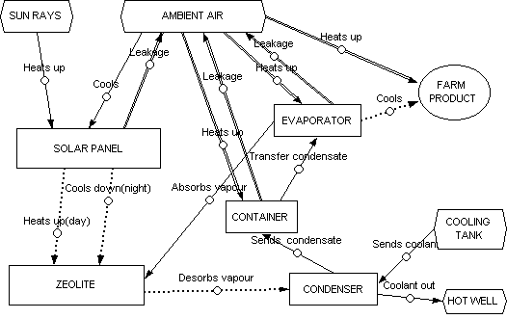

Figure.1. Function model of Solar Cooling System before trimming

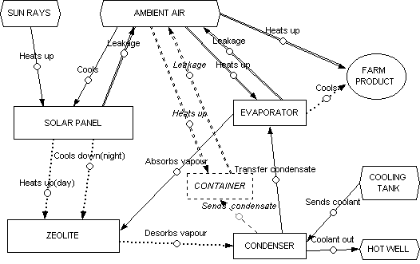

Figure.2. Function model of Solar Cooling System after trimming

