Audacity installation
Download (for windows/linux) from http://audacity.sourceforge.net/download/
Alternatively apt-get install audacity will work in Ubuntu.
Usage
Opening a wav file (File -> Open or Ctrl+O or just drag n’ drop)
There are various options on the toolbar for playing, cutting, analyzing and modifying the audio file.
For more info, go through
http://audacity.sourceforge.net/onlinehelp-1.2/contents.htm
Changing sampling rate
If your wav file is @ 16 kHz and you want to downsample it, change the “Project Rate” (near the bottom of Audacity window) and then do File -> Export and save the modified file at some location.
Audacity 1.3.12 (beta) settings to record mono sound at 8kHz
- Go to Edit->Preferences. Select Devices in the left panel and select “mono” under Channels:
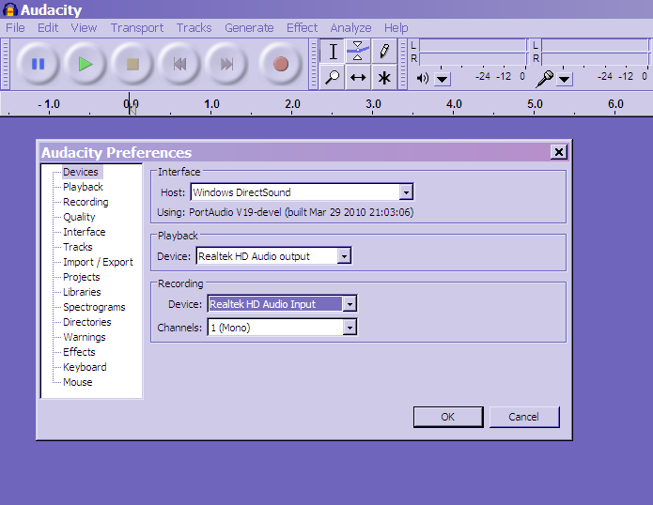
- Next, select “Quality” in the left panel and set the default sampling rate at 8000 Hz (see screenshot on the next page).
