EE 389: ELECTRONIC DESIGN LAB II
Wireless GPS Photo Tagging
Group 10
Aditya Padmawar 06d07023
Prashant saxena 06d07021
Amit Mehta 06d07020
Abstract:
The aim of this project is to tag photographs (clicked by a digital camera) with their GPS co-ordinates. GPS is triggered by an external electronic device (a digital camera) using a switch. When the switch is pressed a photograph is clicked and simultaneously a pulse is wirelessly transmitted to the microprocessor, which logs in the current position co-ordinates into memory. This is then sent to a receiver module which is further used with Google Earth to correlate pictures with location information.

RS-232 output
Wireless Receiver
Computer / Google Earth

Python Script

Fig. 1 Block diagram1: Receiver end – GPS Logger

LCD

Wireless Transmitter
Digital Camera

GPS

SWITCH

Fig. 2 Block Diaram2: Transmitter end

Introduction:
The whole system is divided in two parts, the transmitter end and receiver end (we can see different parts of the system in block diagram above).
At Transmitter end, when a switch is pushed, digital camera is triggered to click a photograph and a signal is sent to uC which in turn triggers the GPS and records the latitude, longitude co-ordinates of the current location. These co-ordinates are then transmitted to the receiver end by a ASK wireless module. The module works at a baud rate of 1200 and a 434MHz frequency. We have used special algorithm involving checking for start byte and stop byte which will eliminate the noise problem completely.
At receiver end, the micro-controller receives the GPS co-ordinates and stores them into a packet bit by bit. When a complete packet is received, it starts to transmit this packet to the computer through the serial port. We have used the RS232 circuit for implementing the protocol.
The packet containing the latitude & longitude co-ordinates is received by the computer at its serial port (COM1). We have written a program in Python which will directly intercept this data and update a file “phototagger.kml” which will later be used for viewing the photo-tagging on Google Earth.
The file “phototagger.kml” contains details about place-marks (i.e. places where the photos were clicked) to be shown. It has the name of the place-mark, latitude, longitude co-ordinates associated with that particular place-mark, and any association of an image or a web-page to it. The Python code accordingly searches for the co-ordinate tag in the *.kml file and updates it with the latest value received from our micro-controller.

Components used:
- GPS module (I-Wave Systems)
- ASK receiver-transmitter module
- Digital camera compatible with CHDK (Canon)
- Max232 for serial port communication
- 16x2 Text LCD
- Microcontroller – Atmega 16L

Project stages:
• Integration of GPS module with uC
• Interfacing the ASK wireless transmitter-receiver with uC
• Recording the GPS co-ordinates from serial port of the computer and storing it in a file used for Google Maps.
• Building the remote triggered switch for camera and CHDK programming.
• Testing and debugging.
• Final PCB layout.

Hardware Aspects:
  - GPS Module:

The GPS module in use is an iWave product using a Sirf Star III chipset. It is capable of operating over a small range of supply voltages: 3.1 to 3.6 volts. The GPS module on switching on tries to get a fix with at least 3 satellites which takes about 20 – 40 seconds. After which it starts showing NMEA protocol strings which are standard for all GPS units. Out of several NMEA string formats, this module shows GGA, GSA, GSV, RMC, GLL and VTG. It updates its data (all these strings) at rate of 1 Hz.

These strings provide different data like satellites in view, date and time besides the geographic location. We select the GPRMC sentence from the data which is the “Recommended Minimum” sentence. It looks somewhat like this:
$GPRMC,204606.000,A,1908.0704,N,07254.2662,E,0.9,307.78,250409,,,*67
All these strings are sent to the microcontroller via serial USART communication at a baud rate of 4800. The transmission pin of GPS module is connected to the D0 (Rx pin of microcontroller). The precision in co‐ordinates of up to 2‐3 meters is essential for this project and this module has an accuracy of that level in open space.

1.2 Microcontroller:

The microcontroller used by us is the Atmega 16L. It is capable of operating in a wide range of supply voltage: 2.7 to 5.5 volts. The atmega receives the NMEA sentences by calling the function USART_Receive(). Then, according to the logic fed in the microcontroller, it parses the string provided and extracts Latitude and Longitude. The value of Latitude and Longitude can be displayed on a text LCD connected to another port of the microcontroller.
Another reason for choosing ATMEGA16L was that if we need to give any signal to the GPS via transmission pin of microcontroller, the voltage level is 5V in ATMEGA 16, while it is 3.3 V in ATMEGA16L, which is below maximum voltage that can be tolerated at any of the GPS pins.

  - ASK Receiver-Transmitter module:
Main features
Frequency Range: 315 / 433.92 MHZ.
Supply Voltage: 3~12V.
Output Power: 4~16dBm
Antenna length about: 23cm for 315 MHz
17cm for 434 MHz
Circuit diagram of the transmitter:
Fig. 3 Transmitter

:
Fig. 4 Circuit diagram of the Receiver

1.4 Text LCD:
We are using a JHD162A 16x2 text LCD for the display of source destination coordinates and other messages. The LCD is connected to the port C of microcontroller. 3 pins (C0, C1 and C2) are used for control signals and 4 pins (C4, C5, C6 and C7) are used as data pins.

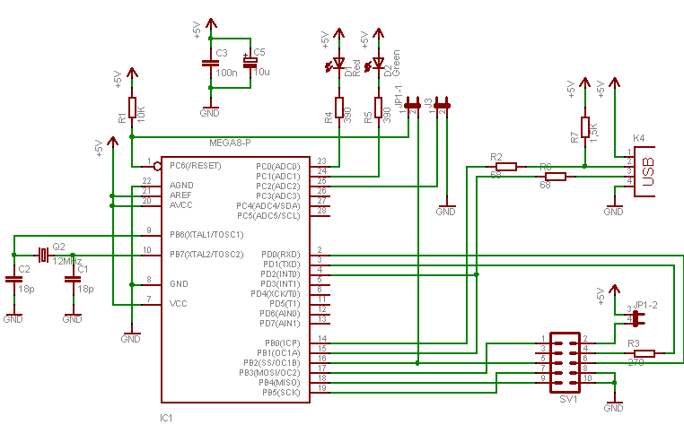
Fig5: Circuit diagram for USB ASP circuit
1.5 USBASP:
For programming the microcontroller we are using standard USB ASP programmer which is an ISP (In System Programmer). The standard circuit is shown here.

1.6 GPS antenna:
A standard GPS antenna AA105 (company-toaglas) has been used for this application. The gain provided by the antenna is well within the range of what is required by the GPS (28+/- 2 dB).

1.7 USB Remote trigger for camera
For our application it was necessary that the digital camera and the GPS device are triggered simultaneously so that the the exact position where the photograph is clicked can be recorded.
In order achieve this objective we have used a camera loaded with CHDK firmware which enables the camera to be triggered by an external on its USB port. The firmware is loaded into the camera at the time of startup. It doesn't do any permanent change to the camera but modifies its functionality to introduce some useful features. Typically the power supply used here should be in the range of 3-4 V. A supply voltage of more than 5V may damage the camera.
We have used following circuit diagram to build the USB remote trigger device.

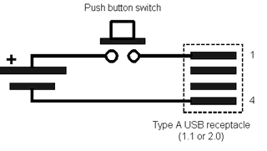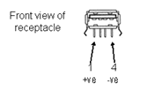
Fig. 6 Remote Triggering
1.8 Data on Hyperterm:
ee$19.1354#72.9051ffee$19.1352#72.9073ffee$19.1348#72.9089ffee$19.1347#72.9091ffee$19.1347#72.9091ffee$19.1343#72.9114ffee$19.1315#72.9160ff
These are the seven coordinate sets of the seven photos clicked. These sets are visible on the hyperterm as soon as the RX module receives them. ‘ee’ and ‘ff’ are the header and footer used for verification.

TX side PCB:
Fig. 7 PCB design of transmitter
RX side PCB:
Fig. 8 PCB of receiver
2. Software Aspect:
2.1 Parsing of GPS Data

Once the USART_Receive function is called it takes in the serial port values bit by bit. We use for loop to store the first 500 characters at each call of this function and store these into an array. Over this array we perform a check whether a $GPRMC has come inside this array somewhere.
$GPRMC,204606.000,A,1908.0704,N,07254.2662,E,0.9,307.78,250409,,,*67
Upon encountering the characters RMC in sequence, we then parse the full sentence, taking out values of Latitude, Longitude and velocity. These values are taken out depending on the no. of commas we encounter after RMC because these values are generally enclosed within 2 commas. What we get for latitude is a string 1908.0704N. This string is converted into a double 1908.0704 by the C function atof( ).

2.2 ASK transmitter-receiver:
At the Transmitter end, microcontroller is connected to the transmitter via
its Tx pin on port D. We can transmit the parsed GPS co-ordinates to the transmitter by using USART_transmit function. We will have to set a baud rate for this serial communication. It has been found that at baud rate of 1200, the module works optimally. The value of UBRR register has to be set to 129 for this purpose.
At the Receiver end, the data pin of ASK receiver goes into an IC CD4010 which is a CMOS/TTL logic converter. The output of the CD4010 IC goes to Rx pin of microcontroller. The microcontroller can receive this data again by USART_receive function with baud rate same as the transmitter (i.e. 1200)
Now the co-ordinates are ready to be transmitted to the computer via a RS232 circuit. The Rx pin comes from microcontroller and the Rx pin goes to the PC.
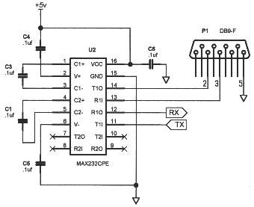
Fig. 9 RS 232 circuit diagram

2.3 Serial data logger:
We have used a software “serial data logger” which automatically converts the data coming on the serial port into a text file (datatoWrite.txt). For this purpose, we have sent the data on serial port in a certain format.
We have sent packets of 20 each of which starts with ‘$’ then 9 digits of longitude, then a ‘#’ and then the remaining 9 digits of latitude. After this stage we have developed a python script which will automatically take these packets of 20 and writes them into a .kml file according to the sequence it was received in. This .kml file is used to view the phototagging on google earth.
2.4 Python script:
The python script reads the datatoWrite.txt file after the job serial data logger is finished. It also reads a default file “phototagger.kml” (with default GPS co-ordinates) and generates a new file “updatetagger.kml” which contains the GPS co-ordinates received from the serial port. See appendix 1 for the code of python file.
Photo Tagging
A kml file is just like an html file, but it is to be used exclusively for Google Earth and Google Maps. When we receive coordinate data on the hyper-terminal via the RS-232 link, we run a Python script which extracts one coordinate set at a time and updates the placemark section of a kml file. Here, a placemark subroutine is shown below. We update the photograph number, photograph link location, latitude and longitude.

<Placemark>
<name>Photo 6</name>
<description><![CDATA[<img src="files/Photo 6.jpg">]]></description>
<LookAt>
<longitude>72.916287</longitude>
<latitude>19.132218</latitude>
<altitude>0</altitude>
<range>530.7338448274799</range>
<tilt>0</tilt>
<heading>-0.001365014669625316</heading>
<altitudeMode>relativeToGround</altitudeMode>
</LookAt>
<styleUrl>#msn_ylw-pushpin_copy10</styleUrl>
<Point>
<coordinates>72.916287,19.132218,0</coordinates>
</Point>
</Placemark>
After updating the kml file in this manner, when we open the file in Google Earth, it straightaway takes us to the location where the photographs were clicked and gives us a view with a suitable zoom, such that all these locations are visible on screen. We can now click on a placemark and see which photo was clicked at that location. On clicking, the local link provided in the img_src bracket will show us the corresponding photo immediately.
We have taken care in the python script that the first co-ordinate that is received is overwritten in place of photo1 (the first photo clicked) and so on. Also we have to update all three tags in a placemark i.e. <coordinates>, < latitude >, < longitude >

Test Results:
We have recorded the GPS locations and clicked photographs at 7 different places in the institute. When a cursor is placed on placemark we can even see the tagged photograph (transferred from the SD card of the camera to the computer on which Google earth is viewed).

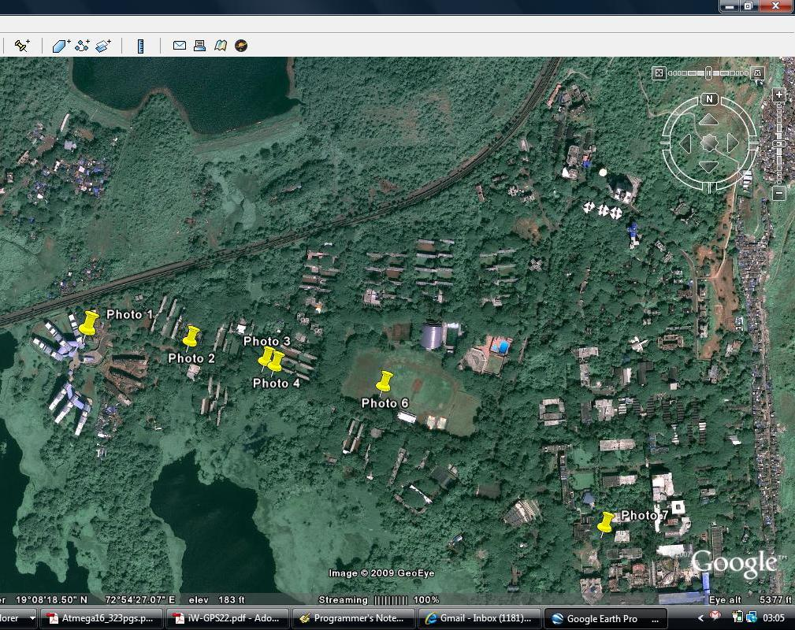
Fig. 10 A snapshot of Google Image

Conclusion and further improvement:
Major part of initially proposed project has been achieved. We have demonstrated that we can triggered a digital camera by an external switch and simultaneously trigger our main circuit to log the GPS co-ordinates. These co-ordinates are then transmitted wirelessly to a computer where it can be used for Google map photo tagging.
Further improvements can be done to the project by transferring the photograph clicked by the digital camera, directly to a computer instead of manual transfer. Another way of achieving these objectives is to embed the GPS co-ordinates of a location where an image is clicked, directly into the JPEG image file. For this purpose we will have to edit image meta-data in a particular way so as to store GPS co-ordinates.

Appendix:

- Python script

from xml.dom.minidom import parse, parseString, Document
import xml.dom
#import serial

def getText(nodelist):
toReturn=""
for node in nodelist:
for nodeChild in node.childNodes:
#print nodeChild.data
toReturn=toReturn+nodeChild.data
return toReturn

def similarTo(name):
for i in range(1,8):
compare=identifier+repr(i)
if name == compare:
return i-1
return -1

fileData = []
f = open("Data2write.txt", "r")
fileContent = f.read()
#print fileContent

for i in fileContent:
fileData.append(i)

toWrite=""
toWriteLatitude = []
toWriteLongitude = []
for j in fileData:
if j == "$":
toWriteLongitude.append(toWrite)
toWrite = ""
elif j == "#":
toWriteLatitude.append(toWrite)
toWrite = ""
elif j == '\n':
continue
else:
toWrite = toWrite+j
toWriteLongitude.append(toWrite)

count = 0
for j in toWriteLongitude:
print j+repr(count)
count=count+1
count = 0
for j in toWriteLatitude:
print j+repr(count)
count=count+1
#packetContent=toWriteArray
data=""
identifier="Photo "

#f = open("edldemo.txt", "a")

dom1 = parse('phototagger.kml') # parse an XML file by name
#print dom1
placemarks = dom1.getElementsByTagName("Placemark")

for mark in placemarks:
idNode=mark.getElementsByTagName("name")
name=getText(idNode)
#print "calling: "+ name
i=similarTo(name)
if i == -1:
#print "cont"
continue
#print i
idNode=mark.getElementsByTagName("coordinates")
idValue=dom1.createTextNode(toWriteLongitude[i+1]+","+toWriteLatitude[i]+",0")
for node in idNode:
node.childNodes[0].data = ""
node.appendChild(idValue)
idNode=mark.getElementsByTagName("longitude")
idValue=dom1.createTextNode(toWriteLongitude[i+1])
for node in idNode:
node.childNodes[0].data = ""
node.appendChild(idValue)
idNode=mark.getElementsByTagName("latitude")
idValue=dom1.createTextNode(toWriteLatitude[i])
for node in idNode:
node.childNodes[0].data = ""
node.appendChild(idValue)

f = open("updtagger.kml", "w")
try:
f.write(dom1.toxml("utf-8"))
f.flush()
finally:
f.close()

References
1. www.atmel.com/dyn/resources/prod_documents/doc2466.pdf
2. www.fischl.de/usbasp/
3. www.datasheetcatalog.com/datasheets_pdf/L/2/9/8/L298.shtml
4. www.netwavegps.com/
5. www.wikipedia.org

