ELECTRONIC DESIGN LAB 2009

SPYBOT



Group Members:

Jitendra Jain (06D07042)

Manoj Meena (06D07043)

Mohan Meena (06D07044)

AIM: To design a Spy-bot having a CCD camera mounted over it and will be
able to send data to the laptop (operator end) via a wireless channel. Robot can be controlled by operator by sending control signals in form of coded sequences from laptop.

Components used
- Renasas motor driver IC
- 2 Stepper motors and wheels
- 9V Dura-cell
- TI C2500 wireless transceiver module
- Atmega 32L SMD microcontroller
- Voltage regulators, 3.3V and 5.0V
- Max 232, Atmega 8 based USPASP programmer for AVRs
- 5 MHz oscillator, 8 MHz crystal, resistors, leds, connectors and capacitors

Basic Block Diagram

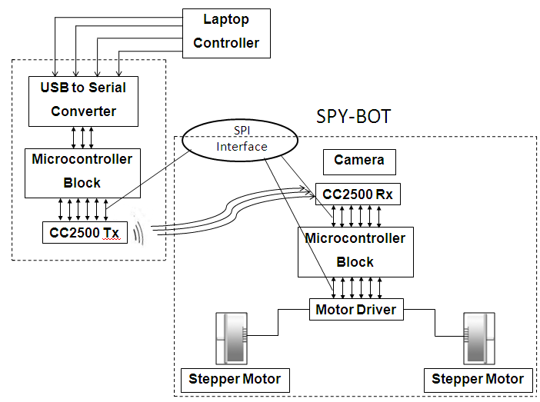

Universal Asynchronous Receiver Transmitter (UART)
UART is usually used for serial communication over a computer or peripheral device serial port. UART takes bytes of data and transmit individual bits in a sequential fashion. In our project we are using UART to transmit the instructions to control the spybot from the laptop. UART has many registers which are used to initialize it. We can initialize the UART as our requirement.

UDR Register:

The UART transmit data buffer register and UART receive data buffer registers share the same I/O address referred to as UART data register or UDR. The transmit data buffer register will be the destination for data written to the UDR register location. Reading the UDR register location will return the contents of the receive data buffer register.

UCSRA Register:
This register is a control and status register which shows receive and transmit status, UDR data register status etc.

UCSRB Register:
We can enable receiver and transmitter using this register.

UCSRC Register:
This register gives the facilities to choose from synchronous and asynchronous mode, data packet length, parity, clock polarity etc.
We have used data packet length 8 bits, no parity check, 1 stop bit and asynchronous mode.

UBRRL and UBRRH Register:
This register is used to set the baud rate. We used the 9600 baud rate.

Serial Peripheral Interface (SPI):
The Serial Peripheral Interface (SPI) allows high-speed synchronous data transfer between the ATmega32 and peripheral devices or between several AVR devices. The ATmega32 SPI includes the following features:
• Full-duplex
• Master or Slave Operation
• LSB First or MSB First Data Transfer
• Seven Programmable Bit Rates
• End of Transmission Interrupt Flag

SPI Master-slave interconnection:

SPCR Register:
This register is used to enable SPI, selection of data order, master/slave selection, clock polarity.
SPDR Register:
The SPI Data Register is a read/write register used for data transfer between the Register File and the SPI Shift Register. Writing to the register initiates data transmission. Reading the register causes the Shift Register Receive buffer to be read.

R2A30414NP motor driver IC

Introduction
- It is a CMOS 48 pin IC having 7 H-bridges which can be driven simultaneously.
- Channel 1-2 and 3-4 can drive stepping motors with up to 512 resolution micro-steps.
- Channel 5 can be used for on-chip FLL control of DC motor
- It requires a main clock OSCIN (typical value 5MHz), two power supplies VCC (typical value 3.3V) and VM (typical value 5V) along with RESET control (3.3V) and three serial control signals namely CS, SCLK and SDATA
- It can output a maximum of 600mA per channel

How to send control signal to R2A30414NP

Control Signals
IC requires a total of four control signal:
- CS (chip select), motor driver IC is selected when CS pin is asserted
- SCLK (serial clock), 16 clocks are required to transfer 16 bit one instruction per CS signal (1.33 MHz in my experiments)
- SDATA (serial data), It is 16 instruction which is serially transferred onto the motor driver IC
- RESET, initializes all registers when pulled low and should be kept high while operation
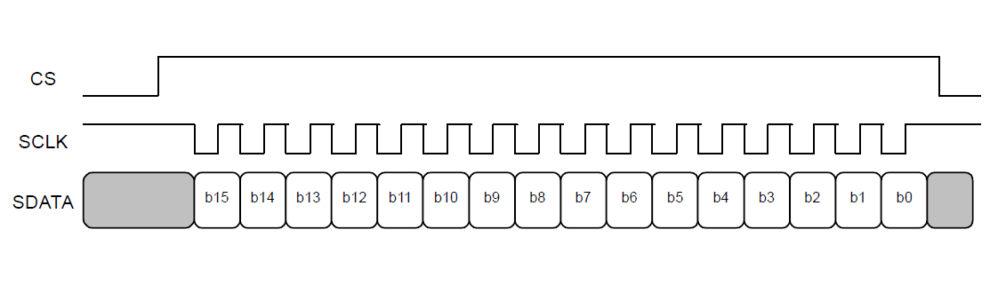

Timing Diagram
SCLK should be smaller than OSCIN. For proper operation of motor driver IC, serial transmission of control signals should be done according to the following timing diagram.
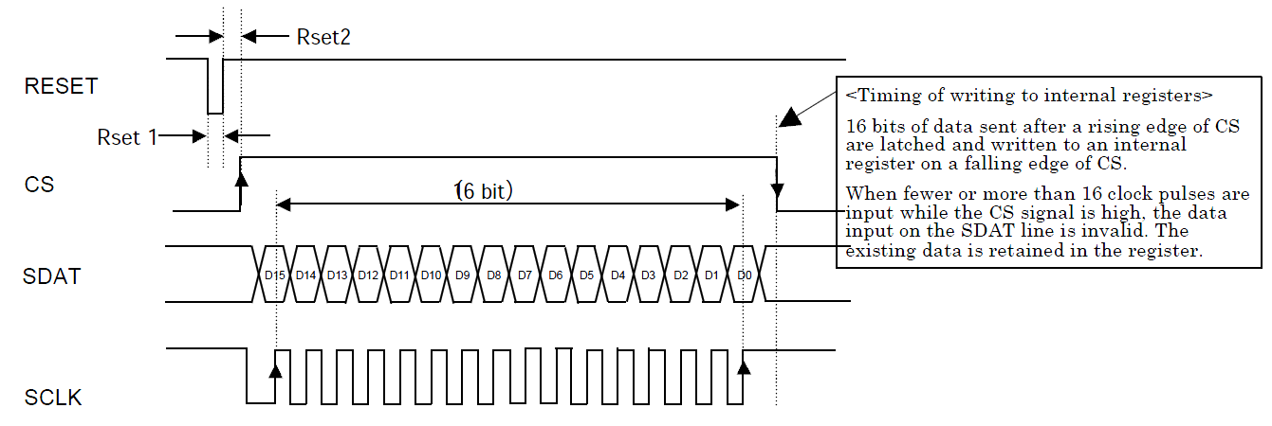
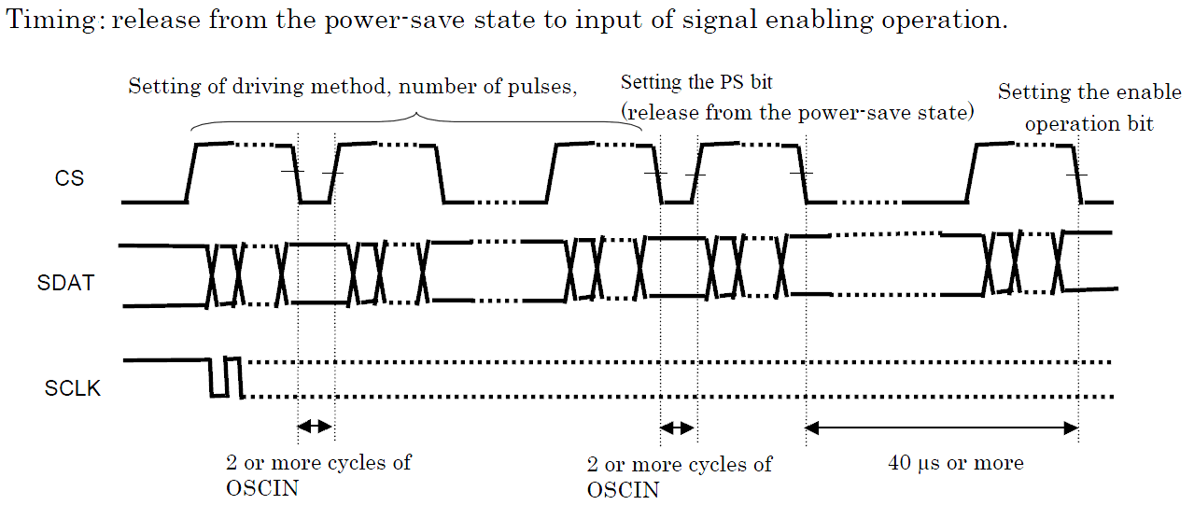

Stepping motor control

Driving mode (Micro stepping)
Micro stepping is used here as the driving mode for stepper motors. Motor driver IC can do micro stepping job up to the resolution of 512 steps per pulse.

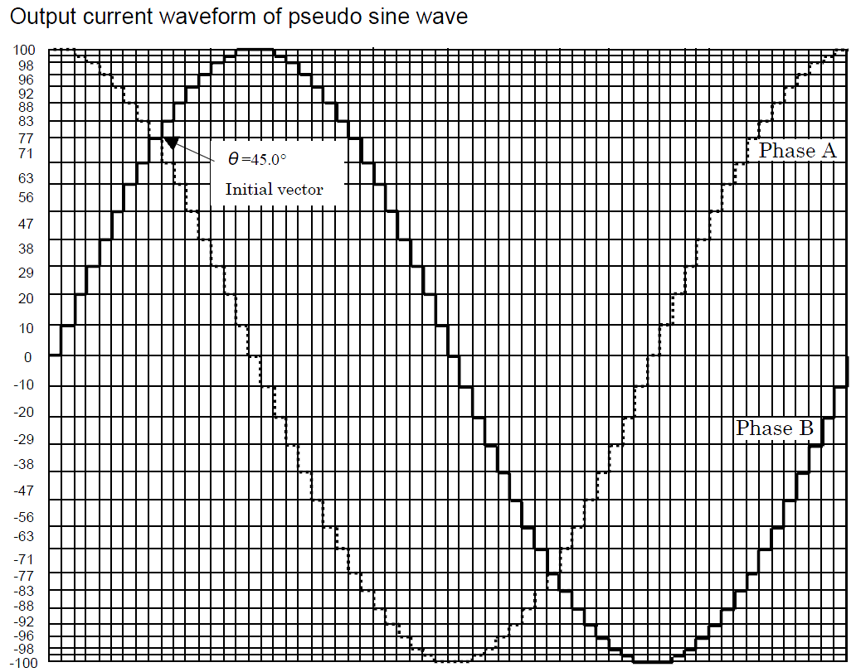
.

Acceleration/deceleration command
Acceleration and deceleration controls are required to avoid noise and jerks while starting and stopping operation. We can accelerate and decelerate motion in terms of discrete pulse rates namely, pulse rate0, pulse rate1, pulse rate2, pulse rate3 and pulse rate4.
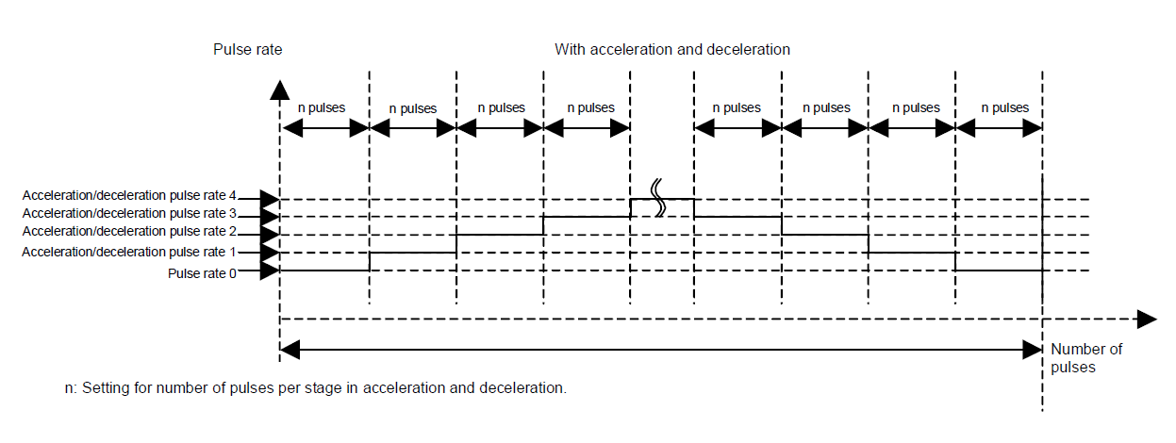
There are fifteen instructions each 16-bit, which need to be transmitted serially.

Explanation: To operate motor driver IC, 16 bit instructions are transmitted serially. These instructions decide the motor control.

What to send?

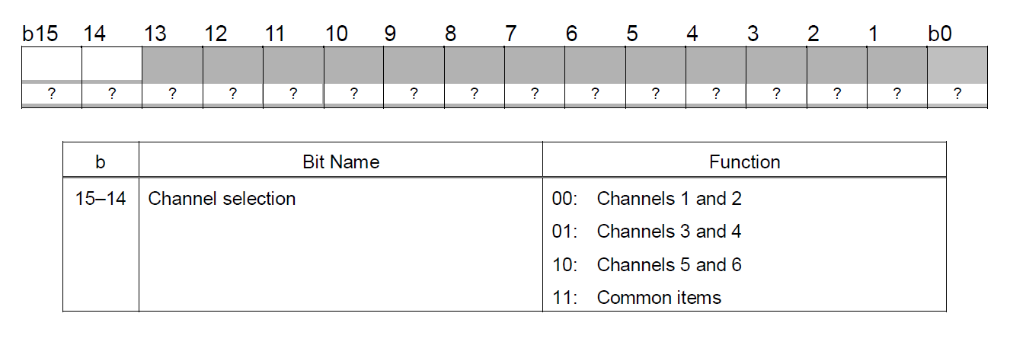

Bit 15-14 decide, which channel to be controlled. Common item register is meant for the following settings.
---software reset
---power supply control
---operation enable control
---decelerate-to-a-stop control
---FLL control for DC motor etc.

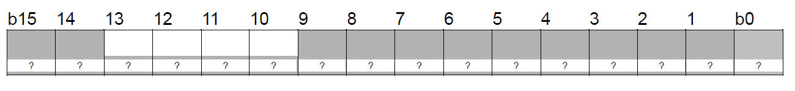

Bit 13-10 are register ID and bit 9-0 defines function of that register

-only those registers are explained which are used for stepping motor control

1.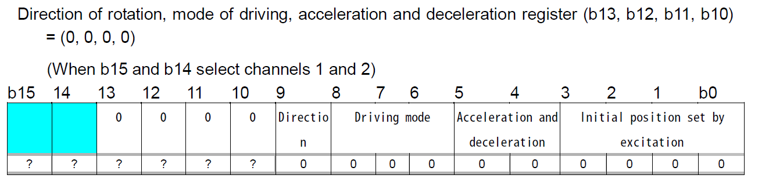
---Micro stepping is used as driving mode
---Both acceleration and deceleration controls are used
---Initial position A, B 100%
2.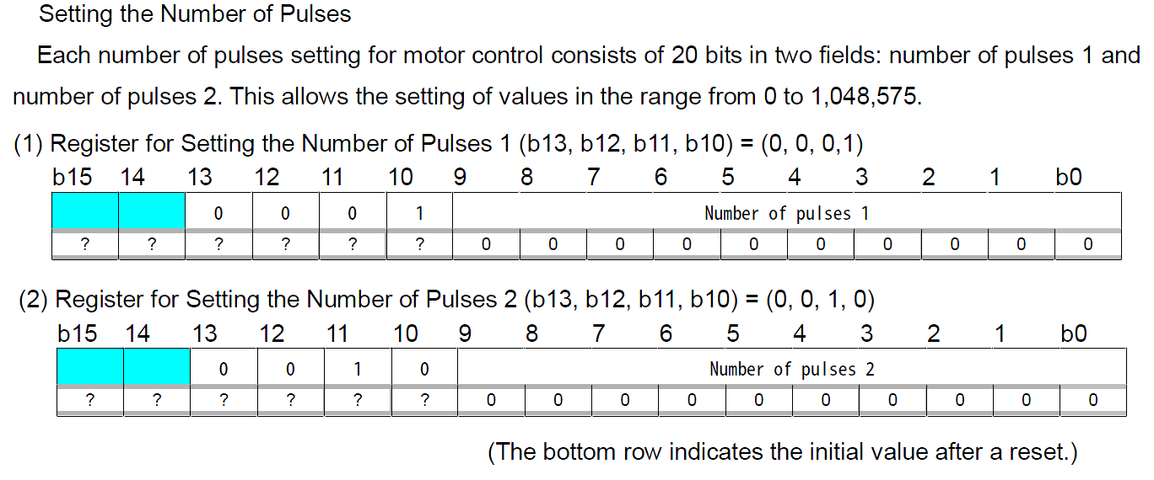
---Total no. pulses = (No. of pulses2) x 1024 + (No. of pulses 1)
3.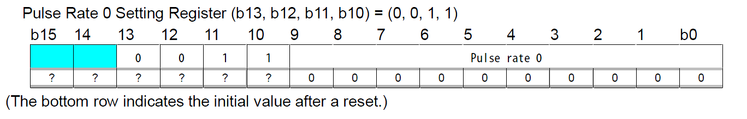
4.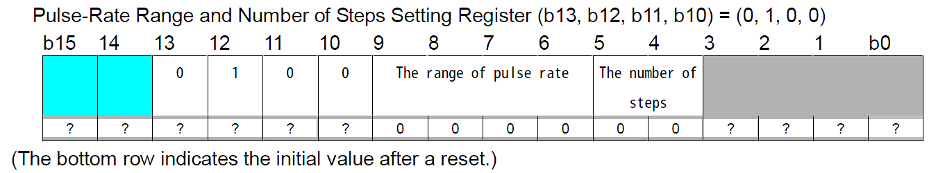
---Sets range of pulse-rate settings (in μs) from 0.2-204.8 μs
---No. of steps (different from stepping motor steps), it is resolution steps of current sine wave. Four resolution steps are available 64, 128, 256 and 512.
5.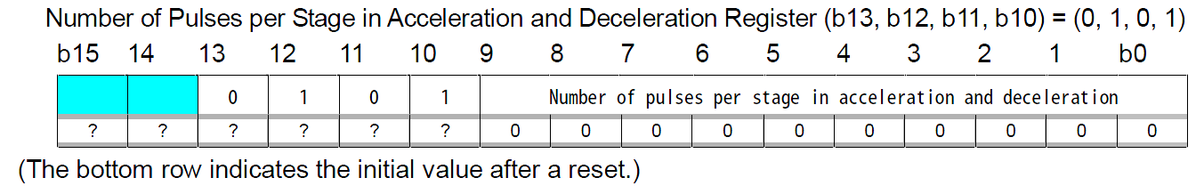

---‘n’ can be set in the range 0-1023.
6.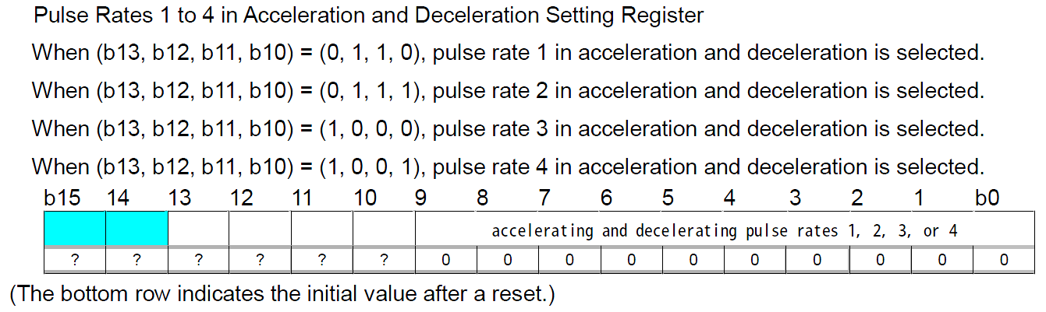
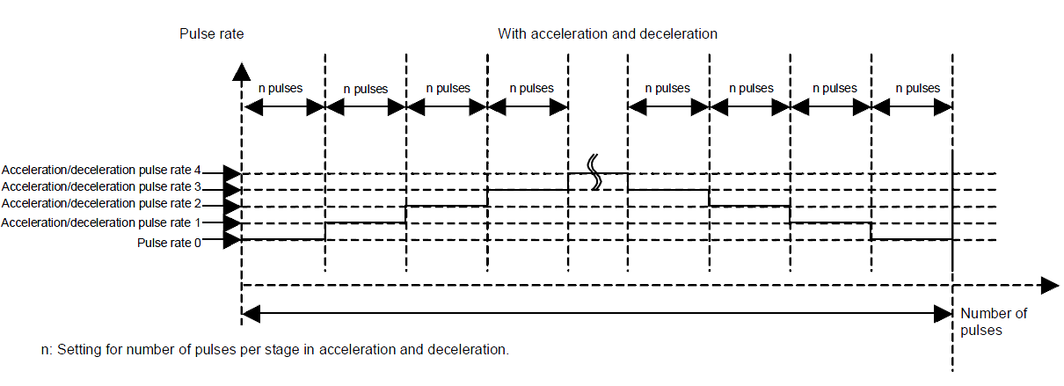
---acc./dec. takes place in 4 stages

7.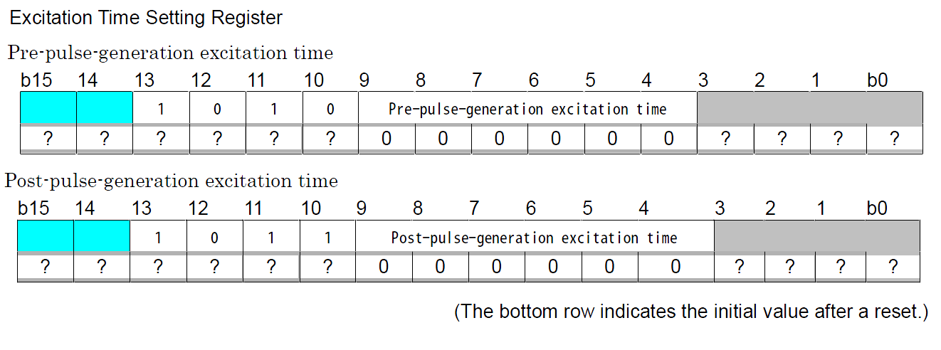
8.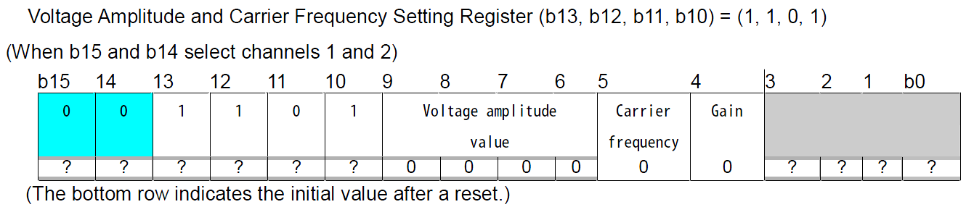
9.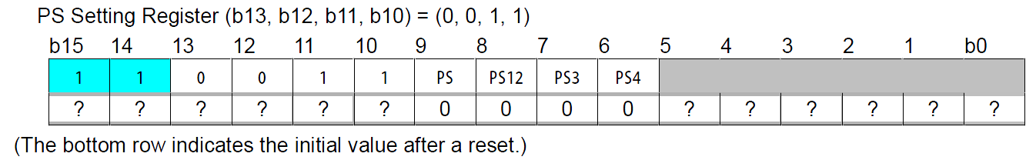
---can be used as instantaneous stop for stepping motor.
10.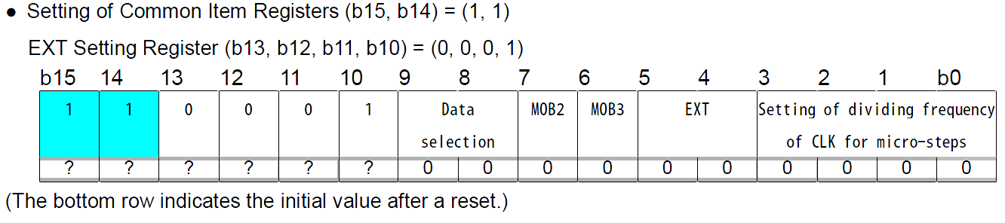

11.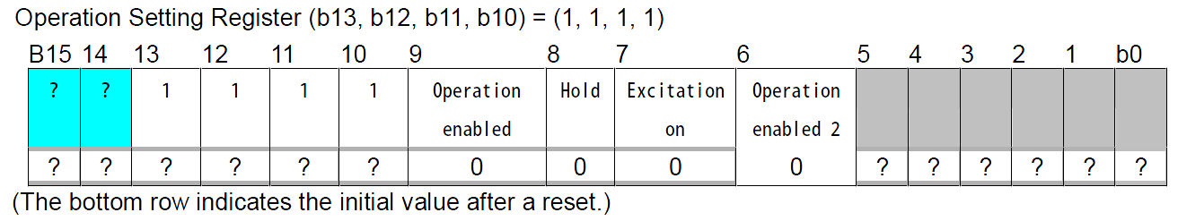
---After setting of this register, motor operation starts.
12.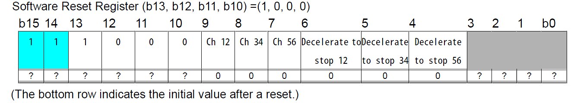
---This register is used to initialize the channels and to give decelerate-to-a-stop command
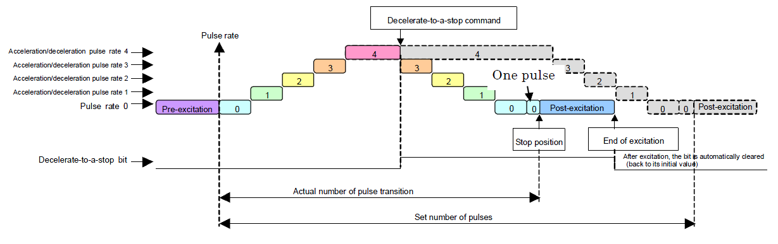

Control signals: Green - CS, Yellow – SDATA, Pink – SCLK (1.33MHz in my case) all 3.3V level
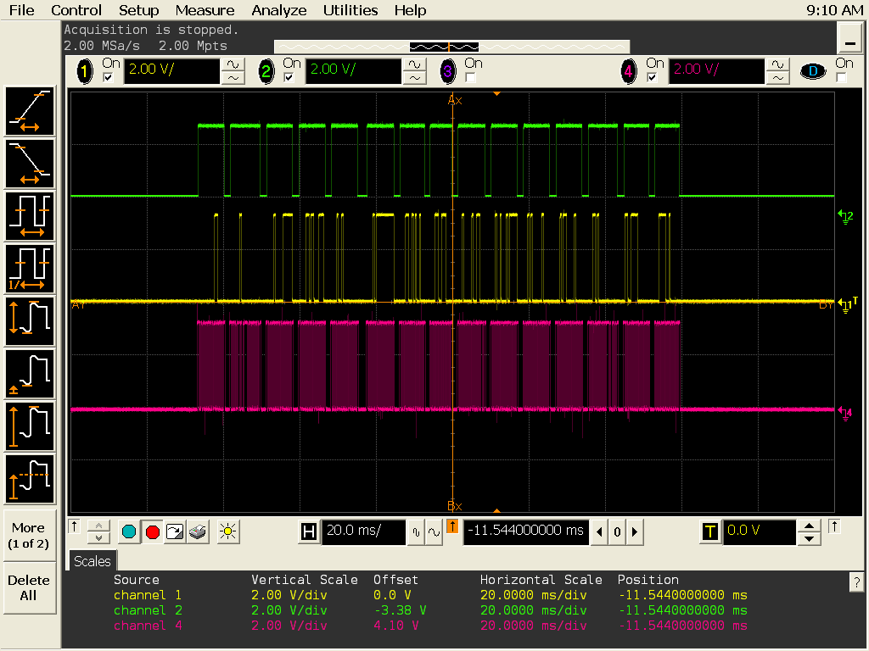
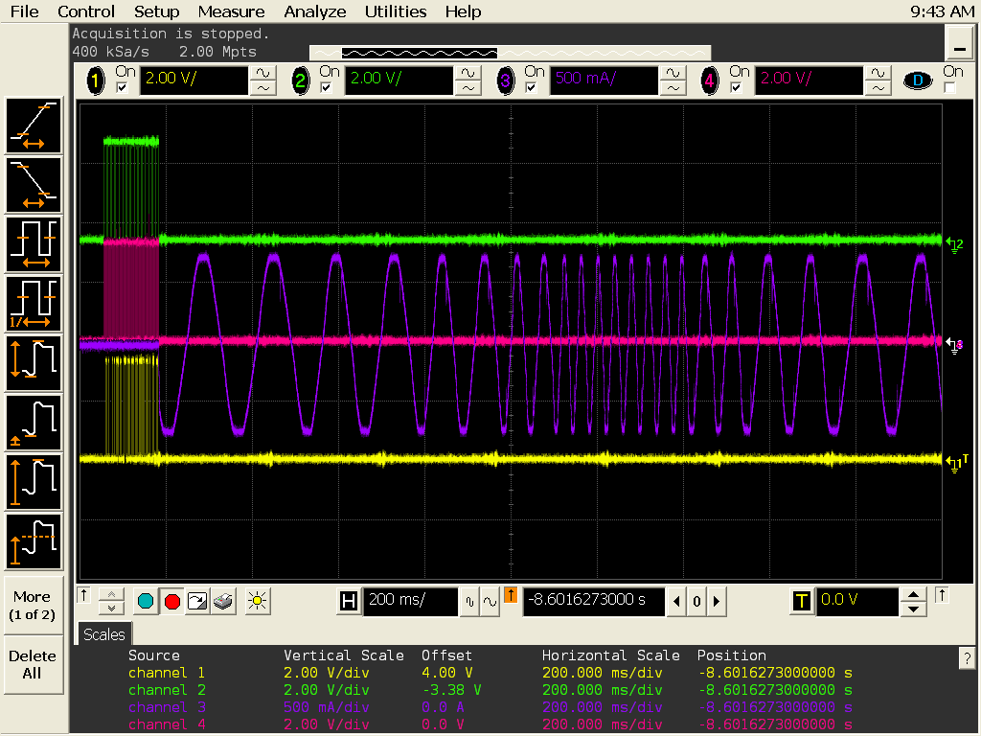

Comments:
---15 instructions (each 16 bits) are serially transmitted on to the motor driver IC.
---Each instruction (set of 16 bits) is transmitted when CS is asserted. These 16 bits are being read on rising edge of SCLK and are latched and then written onto the internal registers of motor driver IC on the falling edge of CS signal.

CC 2500 Wireless Transceiver
CC2500 is a low power 2.4 GHz RF Transceiver. It has 64 bytes transmit/receive FIFOs. It is controlled via SPI interface with the microcontroller with CC2500 as a slave and microcontroller in the master mode. It has several features, some of the important features are
High sensitivity (-104 dBm at 2.4 kBaud)
Low current consumption (13.3 mA in RX at 250 kBaud)
Programmable output power (upto +1 dBm)
Programmable data rate (1.2 to 500 kBaud), well suited to accommodate low resolution video transmission

CC2500 is an integral part of our project. It sends from the transmitter end and receives the signals at remote location (mounted on the spy-bot) to control the spy-bot.
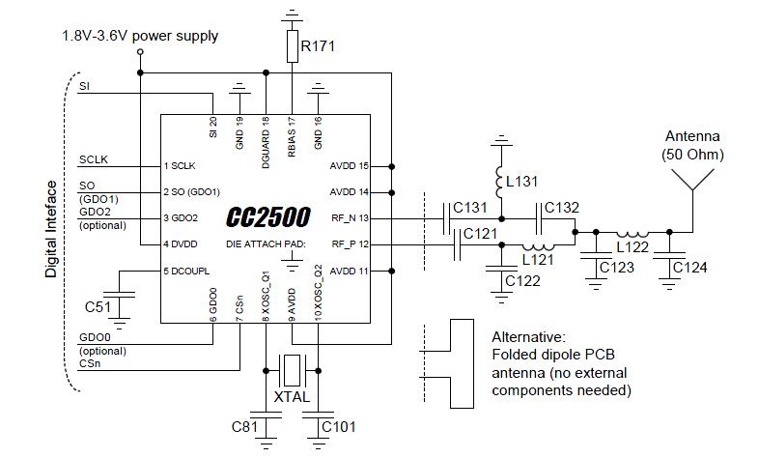
Evaluation circuit of CC2500

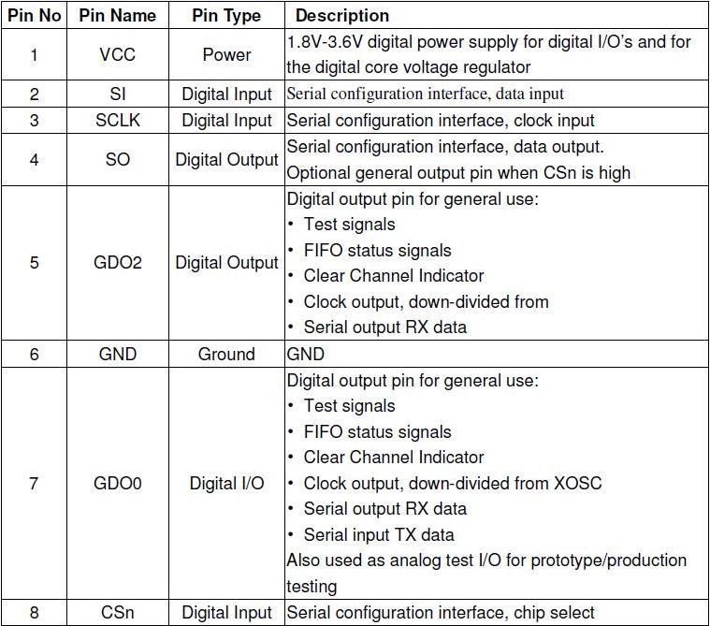
Pin configurations of CC2500

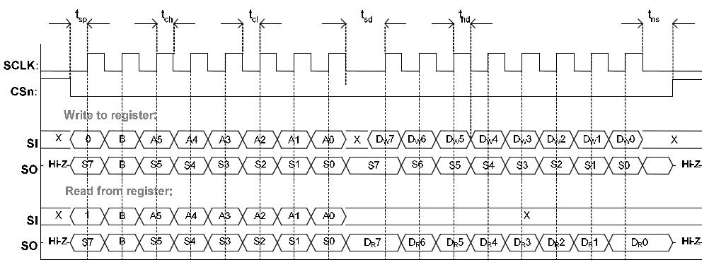
Configuration registers read & write operations timing diagram
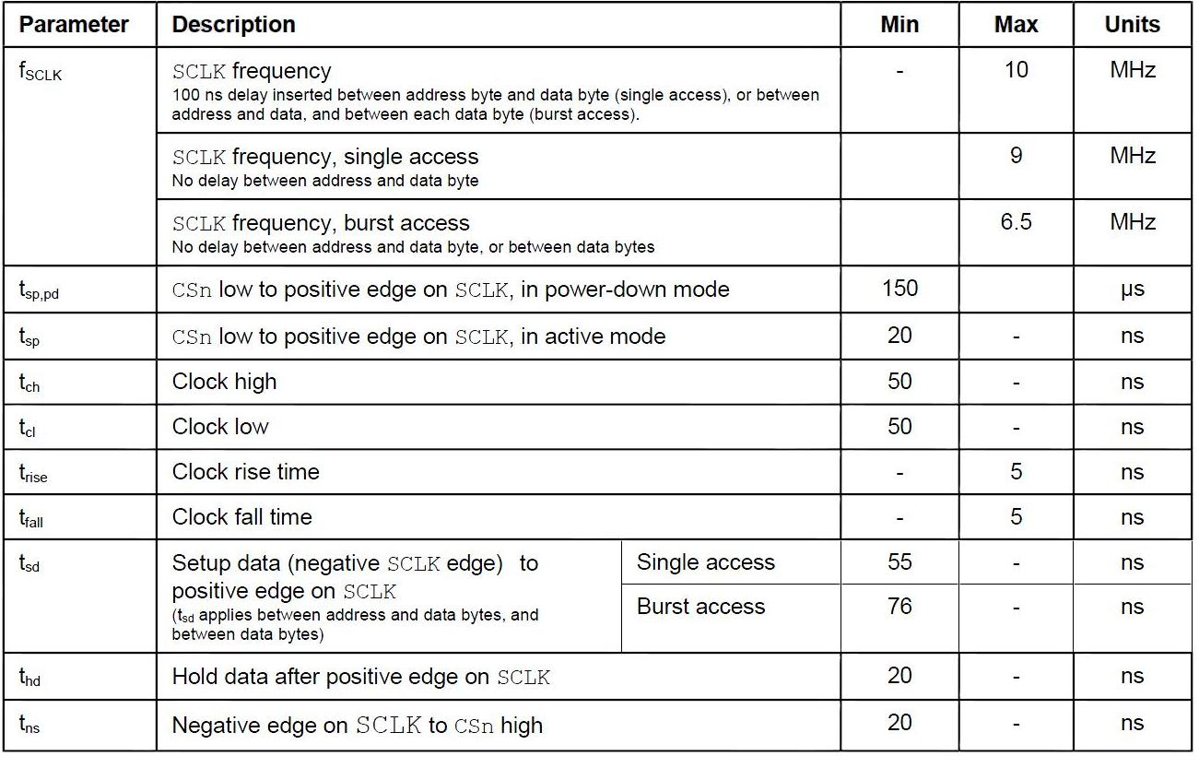

Motor Driver Circuit

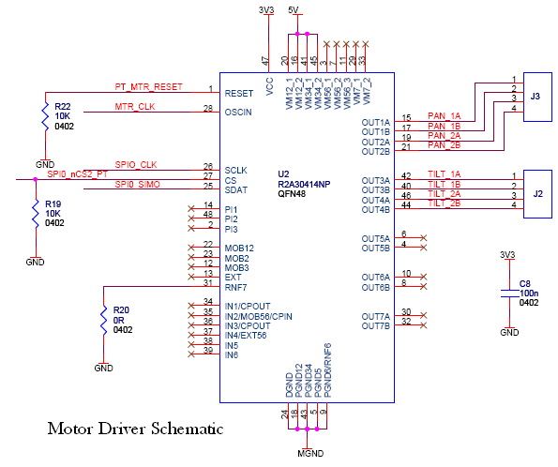

PCB Layouts and Component Placement

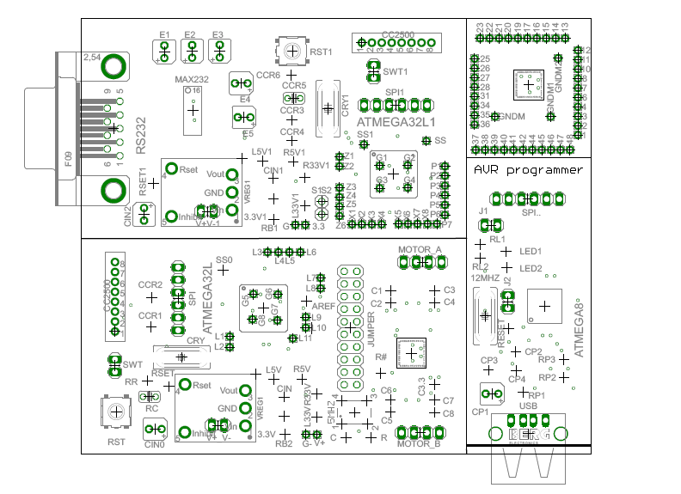
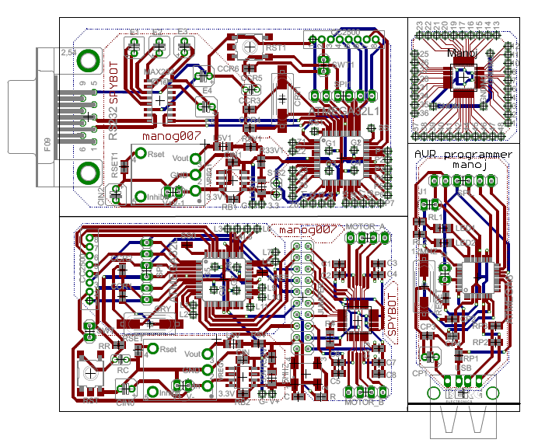

References

Darasheets:
- Atmega32L
- CC2500 wireless transceiver
- Renasas Motor driver IC
- Max 232
- TI voltage regulators 3.3V and 5.0V
- Moon’s stepper motor

APPENDIX

Programming Code

- Transmitter Code
/*
*** EDL LAB PROJECT *** SPY BOT *** 2009 ***
*** GROUP MEMBERS :: JITENDRA, MANOJ, MOHAN ***
*** TRANSMITTER CODE ***
*/

//*** STRAT ***//

#include <avr/io.h>
#include <avr/interrupt.h>
#include <util/delay.h>

/**************** GLOBAL VARIABLE *****************/

int data_tx[100], packetlength = 0, w1, w2;
char data, data_Rx = 0;

/**************** MACROS DEFINATION *****************/

#define fosc 8000000
#define baud 9600
#define mybaud fosc/16/baud-1

#define isHigh(x,y) ((x & (1 << y)) == (1 << y)) ? 1:0
#define isLow(x,y) ((x & (1 << y)) == 0) ? 1:0
#define chkbit(x,b) x & (1 << b) // CHECKS bit status
#define setbit(x,b) x |= _BV(b) // SETS a particular bit
#define clrbit(x,b) x &= ~(_BV(b)) // CLEARS a particular bit
#define togbit(x,b) x ^= _BV(b) // TOGGLES a particular bit

#define MISO_PIN PB6
#define MOSI_PIN PB5
#define SPI_PIN PINB
//#define SRES 0x30
//#define SNOP 0x3D
//#define PARTNUM 0x30
//#define VERSION 0x31
#define F_CPU 8000000L
#define SPI_DDR DDRB
#define SSP_DDR DDRB
#define SS_DD DDB4
#define MOSI_DD DDB5
#define MISO_DD DDB6
#define SCK_DD DDB7
#define CS_DD DDB3
#define POLL_DD DDB1

// Configuration Registers
#define IOCFG2 0x00 // GDO2 output pin configuration
#define IOCFG1 0x01 // GDO1 output pin configuration
#define IOCFG0 0x02 // GDO0 output pin configuration
#define FIFOTHR 0x03 // RX FIFO and TX FIFO thresholds
#define SYNC1 0x04 // Sync word, high byte
#define SYNC0 0x05 // Sync word, low byte
#define PKTLEN 0x06 // Packet length
#define PKTCTRL1 0x07 // Packet automation control
#define PKTCTRL0 0x08 // Packet automation control
#define ADDR 0x09 // Device address
#define CHANNR 0x0A // Channel number
#define FSCTRL1 0x0B // Frequency synthesizer control
#define FSCTRL0 0x0C // Frequency synthesizer control
#define FREQ2 0x0D // Frequency control word, high byte
#define FREQ1 0x0E // Frequency control word, middle byte
#define FREQ0 0x0F // Frequency control word, low byte
#define MDMCFG4 0x10 // Modem configuration
#define MDMCFG3 0x11 // Modem configuration
#define MDMCFG2 0x12 // Modem configuration
#define MDMCFG1 0x13 // Modem configuration
#define MDMCFG0 0x14 // Modem configuration
#define DEVIATN 0x15 // Modem deviation setting
#define MCSM2 0x16 // Main Radio Cntrl State Machine config
#define MCSM1 0x17 // Main Radio Cntrl State Machine config
#define MCSM0 0x18 // Main Radio Cntrl State Machine config
#define FOCCFG 0x19 // Frequency Offset Compensation config
#define BSCFG 0x1A // Bit Synchronization configuration
#define AGCCTRL2 0x1B // AGC control
#define AGCCTRL1 0x1C // AGC control
#define AGCCTRL0 0x1D // AGC control
#define WOREVT1 0x1E // High byte Event 0 timeout
#define WOREVT0 0x1F // Low byte Event 0 timeout
#define WORCTRL 0x20 // Wake On Radio control
#define FREND1 0x21 // Front end RX configuration
#define FREND0 0x22 // Front end TX configuration
#define FSCAL3 0x23 // Frequency synthesizer calibration
#define FSCAL2 0x24 // Frequency synthesizer calibration
#define FSCAL1 0x25 // Frequency synthesizer calibration
#define FSCAL0 0x26 // Frequency synthesizer calibration
#define RCCTRL1 0x27 // RC oscillator configuration
#define RCCTRL0 0x28 // RC oscillator configuration
#define FSTEST 0x29 // Frequency synthesizer cal control
#define PTEST 0x2A // Production test
#define AGCTEST 0x2B // AGC test
#define TEST2 0x2C // Various test settings
#define TEST1 0x2D // Various test settings
#define TEST0 0x2E // Various test settings

// Status registers
#define PARTNUM 0x30 // Part number
#define VERSION 0x31 // Current version number
#define FREQEST 0x32 // Frequency offset estimate
#define LQI 0x33 // Demodulator estimate for link quality
#define RSSI 0x34 // Received signal strength indication
#define MARCSTATE 0x35 // Control state machine state
#define WORTIME1 0x36 // High byte of WOR timer
#define WORTIME0 0x37 // Low byte of WOR timer
#define PKTSTATUS 0x38 // Current GDOx status and packet status
#define VCO_VC_DAC 0x39 // Current setting from PLL cal module
#define TXBYTES 0x3A // Underflow and # of bytes in TXFIFO
#define RXBYTES 0x3B // Overflow and # of bytes in RXFIFO

// Multi byte memory locations
#define PATABLE 0x3E
#define TXFIFO 0x3F
#define RXFIFO 0x3F

// Definitions for burst/single access to registers
#define WRITE_BURST 0x40 // 0100 0000
#define READ_SINGLE 0x80 // 1000 0000
#define READ_BURST 0xC0 // 1100 0000
#define WRITE_SINGLE 0x00 // 0000 0000

/**************** STROBE COMMANDS *****************/

#define SRES 0x30 // Reset chip.
#define SFSTXON 0x31 // Enable and calibrate frequency synthesizer (if MCSM0.FS_AUTOCAL=1).
// If in RX/TX: Go to a wait state where only the synthesizer is
// running (for quick RX / TX turnaround).
#define SXOFF 0x32 // Turn off crystal oscillator.
#define SCAL 0x33 // Calibrate frequency synthesizer and turn it off
// (enables quick start).
#define SRX 0x34 // Enable RX. Perform calibration first if coming from IDLE and
// MCSM0.FS_AUTOCAL=1.
#define STX 0x35 // In IDLE state: Enable TX. Perform calibration first if
// MCSM0.FS_AUTOCAL=1. If in RX state and CCA is enabled:
// Only go to TX if channel is clear.
#define SIDLE 0x36 // Exit RX / TX, turn off frequency synthesizer and exit
// Wake-On-Radio mode if applicable.
#define SAFC 0x37 // Perform AFC adjustment of the frequency synthesizer
#define SWOR 0x38 // Start automatic RX polling sequence (Wake-on-Radio)
#define SPWD 0x39 // Enter power down mode when CSn goes high.
#define SFRX 0x3A // Flush the RX FIFO buffer.
#define SFTX 0x3B // Flush the TX FIFO buffer.
#define SWORRST 0x3C // Reset real time clock.
#define SNOP 0x3D // No operation. May be used to pad strobe commands to two
// bytes for simpler software.

//----------------------------------------------------------------------------------
// Chip Status Byte
//----------------------------------------------------------------------------------

// Bit fields in the chip status byte
#define STATUS_CHIP_RDYn_BM 0x80
#define STATUS_STATE_BM 0x70
#define STATUS_FIFO_BYTES_AVAILABLE_BM 0x0F

// Chip states
#define STATE_IDLE 0x00
#define STATE_RX 0x10
#define STATE_TX 0x20
#define STATE_FSTXON 0x30
#define STATE_CALIBRATE 0x40
#define STATE_SETTLING 0x50
#define STATE_RX_OVERFLOW 0x60
#define STATE_TX_UNDERFLOW 0x70

//----------------------------------------------------------------------------------
// Other register bit fields
//----------------------------------------------------------------------------------
#define LQI_CRC_OK_BM 0x80
#define LQI_EST_BM 0x7F

/**************** UASRT_INIT *****************/

void USART_Init(unsigned int ubrr)
{
UBRRH = (unsigned char)(ubrr >> 8);
UBRRL = (unsigned char) ubrr;
UCSRC = (1 << URSEL) | (1 << UCSZ1) | (1 << UCSZ0); // Asyn mode, data bit 8, 1 stop bit, no parity,
UCSRB = (1 << TXEN) | (1 << RXEN) | (0 << UCSZ2); // Enable receiver, tansmitter
}

char USART_Read(void)
{
while(!(UCSRA & (1<<RXC))) //Wait untill a data is available
{ //Do nothing
}
// Now USART has got data from host and is available in buffer.
return UDR;
}

void USART_transmit(int data)
{
while(!(UCSRA &(1<<UDRE)));
UDR = data;
}

/**************** SPI_INIT *****************/

void spi_init(void)
{
SPI_DDR |= (_BV(MOSI_DD) | _BV(SCK_DD));
SPI_DDR &= ~(_BV(MISO_DD));
SPI_DDR |= (_BV(CS_DD));
SPI_DDR &= ~(_BV(POLL_DD));

SSP_DDR |= (_BV(SS_DD));

SPCR |= _BV(MSTR) | _BV(SPR1) | _BV(SPR0) ;
SPCR |= _BV(SPE);
}

int spi_write(int data)
{
SPDR = data; // DATA to be transmitted
while(! (SPSR & (1 << SPIF))); // Check SPIF flag, when set to 1 -> transmiision is done
return SPDR; // Return (SPDR)
}

/**************** CC2500_FUNCT *****************/

void chip_rdy(void)
{
while ((PINB & 0b01000000) == 0b01000000) // Chip ready condition, active low
{;}
}

int read_reg(int address)
{
clrbit(PORTB,PB3);
chip_rdy();
w1 = spi_write(READ_SINGLE | address);
int rc=spi_write(0x00);
setbit(PORTB,PB3);
return(rc);
}

void write_reg(int address, int add_value)
{
clrbit(PORTB, PB3);
chip_rdy();
w1 = spi_write(address);
w2 = spi_write(add_value);
setbit(PORTB, PB3);
}

void config_cc(void)
{
write_reg(FSCTRL1, 0x07);
write_reg(FSCTRL0, 0x00);
write_reg(FREQ2, 0x5D);
write_reg(FREQ1, 0x93);
write_reg(FREQ0, 0xB1);
write_reg(MDMCFG4, 0x2D);
write_reg(MDMCFG3, 0x3B);
write_reg(MDMCFG2, 0x73);
write_reg(MDMCFG1, 0x22);
write_reg(MDMCFG0, 0xF8);
write_reg(CHANNR, 0x00);
write_reg(DEVIATN, 0x00);
write_reg(FREND1, 0xB6);
write_reg(FREND0, 0x10);
write_reg(MCSM0, 0x18);
write_reg(MCSM1, 0x3F);
write_reg(FOCCFG, 0x1D);
write_reg(BSCFG, 0x1C);
write_reg(AGCCTRL2, 0xC7);
write_reg(AGCCTRL1, 0x00);
write_reg(AGCCTRL0, 0xB2);
write_reg(FSCAL3, 0xEA);
write_reg(FSCAL2, 0x0A);
write_reg(FSCAL1, 0x00);
write_reg(FSCAL0, 0x11);
write_reg(FSTEST, 0x59);
write_reg(TEST2, 0x88);
write_reg(TEST1, 0x31);
write_reg(TEST0, 0x0B);
write_reg(IOCFG2, 0x29);
write_reg(IOCFG0, 0x06);
write_reg(PKTCTRL1, 0x05);
write_reg(PKTCTRL0, 0x05);
write_reg(ADDR, 0x01);
write_reg(PKTLEN, 0xFF);
write_reg(PATABLE, 0xFB);
}

int cc_status(void)
{
clrbit(PORTB,PB3);
chip_rdy ();
int rc = spi_write(SNOP);
setbit(PORTB,PB3);
return (rc);
}

void stb_cc(int stb_address)
{
clrbit(PORTB,PB3);
chip_rdy ();
w1 = spi_write(stb_address);
setbit(PORTB,PB3);
_delay_us(10);
}

void cc_first(void)
{
setbit(PORTB,PB3);
_delay_us(30);
clrbit(PORTB,PB3);
_delay_us(30);
setbit(PORTB,PB3);
_delay_us(45);
clrbit(PORTB,PB3);
chip_rdy();
w1 = spi_write(SRES);
chip_rdy();
setbit(PORTB,PB3);
}

void prepare_packet(void)
{
int payloadlength = (data_Rx - 50);
data_tx[0] = payloadlength;
data_tx[1] = read_reg(ADDR);
for(int i = 2; i <= payloadlength; i++)
{
data_tx[i] = i; // Creating packet of dummy values
}
packetlength=payloadlength;
}

void txwritepacket(void)
{
int add_fifo = (WRITE_BURST | TXFIFO);
clrbit(PORTB, PB3);
chip_rdy();
w1 = spi_write(add_fifo);
for (int i = 0; i <= packetlength; i++)
{
w1 = spi_write(data_tx[i]);
}
setbit(PORTB, PB3);
}

void transmitpacket(void)
{
stb_cc(STX);
_delay_ms(100);
}

void delay (unsigned int wait)
{
unsigned int i;
for (i = 0; i < wait; i ++)
{
_delay_ms(100);
}
}

/**************** MAIN_BODY *****************/

int main(void)
{
DDRA=0xFF;
DDRC=0xFF;
// DDRD=0xFF;

PORTC = 0xFF;

spi_init();
cc_first();
stb_cc(SIDLE);
config_cc();

USART_Init(mybaud);

while(1)
{
data_Rx = USART_Read(); // Data to be transmitted to SPDR register
PORTC = 0x00;
prepare_packet(); // Make packet
_delay_ms(1);
txwritepacket(); // TX FIFO WRITE
_delay_ms(1);
transmitpacket(); // Transmit Packet
_delay_ms(1);

PORTC = 0xAA;
delay(10);
PORTC = 0xFF;
delay(10);
PORTC = 0x55;
}
}

//*** END ***//

Receiver Code
/*
*** EDL LAB PROJECT *** SPY BOT *** 2009 ***
*** GROUP MEMBERS :: JITENDRA, MANOJ, MOHAN ***
*** RECEIVER CODE ***
*/

//*** STRAT ***//

#include <avr/io.h>
#include <avr/interrupt.h>
#include <util/delay.h>

/*********************** GLOBAL_VARIABLE *********************************************/

int data_rx[64] = {0x00}, payloadlength = 0, w1, w2;
char data, data_Rx = 0;

/*********************** MACROS_DEF *********************************************/

#define fosc 8000000
#define baud 9600
#define mybaud fosc/16/baud-1

#define isHigh(x,y) ((x&(1<<y))==(1<<y)) ? 1:0
#define isLow(x,y) ((x&(1<<y))==0) ? 1:0
#define chkbit(x,b) x & (1 << b) // CHECKS bit status
#define setbit(x,b) x |= _BV(b) // SETS a particular bit
#define clrbit(x,b) x &= ~(_BV(b)) // CLEARS a particular bit
#define togbit(x,b) x ^= _BV(b) // TOGGLES a particular bit

#define MISO_PIN PB6
#define MOSI_PIN PB5
#define SPI_PIN PINB
//#define SRES 0x30
//#define SNOP 0x3D
//#define PARTNUM 0x30
//#define VERSION 0x31
#define F_CPU 8000000L
#define SPI_DDR DDRB
#define SSP_DDR DDRB
#define SS_DD DDB4
#define MOSI_DD DDB5
#define MISO_DD DDB6
#define SCK_DD DDB7
#define CS_DD DDB3
#define POLL_DD DDB2

// Configuration Registers
#define IOCFG2 0x00 // GDO2 output pin configuration
#define IOCFG1 0x01 // GDO1 output pin configuration
#define IOCFG0 0x02 // GDO0 output pin configuration
#define FIFOTHR 0x03 // RX FIFO and TX FIFO thresholds
#define SYNC1 0x04 // Sync word, high byte
#define SYNC0 0x05 // Sync word, low byte
#define PKTLEN 0x06 // Packet length
#define PKTCTRL1 0x07 // Packet automation control
#define PKTCTRL0 0x08 // Packet automation control
#define ADDR 0x09 // Device address
#define CHANNR 0x0A // Channel number
#define FSCTRL1 0x0B // Frequency synthesizer control
#define FSCTRL0 0x0C // Frequency synthesizer control
#define FREQ2 0x0D // Frequency control word, high byte
#define FREQ1 0x0E // Frequency control word, middle byte
#define FREQ0 0x0F // Frequency control word, low byte
#define MDMCFG4 0x10 // Modem configuration
#define MDMCFG3 0x11 // Modem configuration
#define MDMCFG2 0x12 // Modem configuration
#define MDMCFG1 0x13 // Modem configuration
#define MDMCFG0 0x14 // Modem configuration
#define DEVIATN 0x15 // Modem deviation setting
#define MCSM2 0x16 // Main Radio Cntrl State Machine config
#define MCSM1 0x17 // Main Radio Cntrl State Machine config
#define MCSM0 0x18 // Main Radio Cntrl State Machine config
#define FOCCFG 0x19 // Frequency Offset Compensation config
#define BSCFG 0x1A // Bit Synchronization configuration
#define AGCCTRL2 0x1B // AGC control
#define AGCCTRL1 0x1C // AGC control
#define AGCCTRL0 0x1D // AGC control
#define WOREVT1 0x1E // High byte Event 0 timeout
#define WOREVT0 0x1F // Low byte Event 0 timeout
#define WORCTRL 0x20 // Wake On Radio control
#define FREND1 0x21 // Front end RX configuration
#define FREND0 0x22 // Front end TX configuration
#define FSCAL3 0x23 // Frequency synthesizer calibration
#define FSCAL2 0x24 // Frequency synthesizer calibration
#define FSCAL1 0x25 // Frequency synthesizer calibration
#define FSCAL0 0x26 // Frequency synthesizer calibration
#define RCCTRL1 0x27 // RC oscillator configuration
#define RCCTRL0 0x28 // RC oscillator configuration
#define FSTEST 0x29 // Frequency synthesizer cal control
#define PTEST 0x2A // Production test
#define AGCTEST 0x2B // AGC test
#define TEST2 0x2C // Various test settings
#define TEST1 0x2D // Various test settings
#define TEST0 0x2E // Various test settings

// Status registers
#define PARTNUM 0x30 // Part number
#define VERSION 0x31 // Current version number
#define FREQEST 0x32 // Frequency offset estimate
#define LQI 0x33 // Demodulator estimate for link quality
#define RSSI 0x34 // Received signal strength indication
#define MARCSTATE 0x35 // Control state machine state
#define WORTIME1 0x36 // High byte of WOR timer
#define WORTIME0 0x37 // Low byte of WOR timer
#define PKTSTATUS 0x38 // Current GDOx status and packet status
#define VCO_VC_DAC 0x39 // Current setting from PLL cal module
#define TXBYTES 0x3A // Underflow and # of bytes in TXFIFO
#define RXBYTES 0x3B // Overflow and # of bytes in RXFIFO

// Multi byte memory locations
#define PATABLE 0x3E
#define TXFIFO 0x3F
#define RXFIFO 0x3F

// Definitions for burst/single access to registers
#define WRITE_BURST 0x40 // 0100 0000
#define READ_SINGLE 0x80 // 1000 0000
#define READ_BURST 0xC0 // 1100 0000
#define WRITE_SINGLE 0x00 // 0000 0000

// Strobe commands
#define SRES 0x30 // Reset chip.
#define SFSTXON 0x31 // Enable and calibrate frequency synthesizer (if MCSM0.FS_AUTOCAL=1).
// If in RX/TX: Go to a wait state where only the synthesizer is
// running (for quick RX / TX turnaround).
#define SXOFF 0x32 // Turn off crystal oscillator.
#define SCAL 0x33 // Calibrate frequency synthesizer and turn it off
// (enables quick start).
#define SRX 0x34 // Enable RX. Perform calibration first if coming from IDLE and
// MCSM0.FS_AUTOCAL=1.
#define STX 0x35 // In IDLE state: Enable TX. Perform calibration first if
// MCSM0.FS_AUTOCAL=1. If in RX state and CCA is enabled:
// Only go to TX if channel is clear.
#define SIDLE 0x36 // Exit RX / TX, turn off frequency synthesizer and exit
// Wake-On-Radio mode if applicable.
#define SAFC 0x37 // Perform AFC adjustment of the frequency synthesizer
#define SWOR 0x38 // Start automatic RX polling sequence (Wake-on-Radio)
#define SPWD 0x39 // Enter power down mode when CSn goes high.
#define SFRX 0x3A // Flush the RX FIFO buffer.
#define SFTX 0x3B // Flush the TX FIFO buffer.
#define SWORRST 0x3C // Reset real time clock.
#define SNOP 0x3D // No operation. May be used to pad strobe commands to two
// bytes for simpler software.

//----------------------------------------------------------------------------------
// Chip Status Byte
//----------------------------------------------------------------------------------

// Bit fields in the chip status byte
#define STATUS_CHIP_RDYn_BM 0x80
#define STATUS_STATE_BM 0x70
#define STATUS_FIFO_BYTES_AVAILABLE_BM 0x0F

// Chip states
#define STATE_IDLE 0x00
#define STATE_RX 0x10
#define STATE_TX 0x20
#define STATE_FSTXON 0x30
#define STATE_CALIBRATE 0x40
#define STATE_SETTLING 0x50
#define STATE_RX_OVERFLOW 0x60
#define STATE_TX_UNDERFLOW 0x70

//----------------------------------------------------------------------------------
// Other register bit fields
//----------------------------------------------------------------------------------
#define LQI_CRC_OK_BM 0x80
#define LQI_EST_BM 0x7F

/*********************** SPI_INIT *********************************************/

void spi_init(void)
{
SPI_DDR |= (_BV(MOSI_DD) | _BV(SCK_DD));
SPI_DDR &= ~(_BV(MISO_DD));
SPI_DDR &= ~(_BV(POLL_DD));
SPI_DDR |= (_BV(CS_DD));

SSP_DDR |= (_BV(SS_DD));

SPCR |= _BV(MSTR) | _BV(SPR1) | _BV(SPR0) ;
SPCR |= _BV(SPE);
}

int spi_write(int data)
{
SPDR = data; // DATA to be transmitted
while(! (SPSR & (1 << SPIF))); // Check SPIF flag, when set to 1 -> transmiision is done
return SPDR; // Return (SPDR)
}

void chip_rdy(void)
{
while ((PINB & 0b01000000) == 0b01000000) // Chip ready condition, active low
{;}
}

/*********************** UART_INIT *********************************************/

void USART_Init(unsigned int ubrr)
{
UBRRH = (unsigned char)(ubrr >> 8);
UBRRL = (unsigned char) ubrr;
UCSRC = (1 << URSEL)|(1 << UCSZ1)|(1 << UCSZ0); // Asyn mode, data bit 8, 1 stop bit, no parity,
UCSRB = (1 << TXEN)|(1 << RXEN)|(0 << UCSZ2); // Enable receiver, tansmitter
}

char USART_Read(void)
{
while(!(UCSRA & (1 << RXC))) //Wait untill a data is available
{ //Do nothing
}
// Now USART has got data from host and is available in buffer.
return UDR;
}

void USART_transmit(int data)
{
while(!(UCSRA &(1<<UDRE)));
UDR = data;
}

/*********************** CC2500_FUCNT *********************************************/

int read_reg (int address)
{
clrbit(PORTB,PB3);
chip_rdy ();
w1 = spi_write(READ_SINGLE | address);
int rc = spi_write(0x00);
setbit(PORTB,PB3);
return (rc);
}

void write_reg(int address, int add_value)
{
clrbit (PORTB, PB3);
chip_rdy();
w1 = spi_write(address);
w2 = spi_write(add_value);
setbit (PORTB, PB3);
}

void config_cc()
{
write_reg(FSCTRL1, 0x07);
write_reg(FSCTRL0, 0x00);
write_reg(FREQ2, 0x5d);
write_reg(FREQ1, 0x93);
write_reg(FREQ0, 0xB1);
write_reg(MDMCFG4, 0x2D);
write_reg(MDMCFG3, 0x3B);
write_reg(MDMCFG2, 0x73);
write_reg(MDMCFG1, 0x22);
write_reg(MDMCFG0, 0xF8);
write_reg(CHANNR, 0x00);
write_reg(DEVIATN, 0x00);
write_reg(FREND1, 0xB6);
write_reg(FREND0, 0x10);
write_reg(MCSM0, 0x18);
write_reg(MCSM1, 0x3F);
write_reg(FOCCFG, 0x1D);
write_reg(BSCFG, 0x1C);
write_reg(AGCCTRL2, 0xC7);
write_reg(AGCCTRL1, 0x00);
write_reg(AGCCTRL0, 0xB2);
write_reg(FSCAL3, 0xEA);
write_reg(FSCAL2, 0x0A);
write_reg(FSCAL1, 0x00);
write_reg(FSCAL0, 0x11);
write_reg(FSTEST, 0x59);
write_reg(TEST2, 0x88);
write_reg(TEST1, 0x31);
write_reg(TEST0, 0x0B);
write_reg(IOCFG2, 0x06);
write_reg(IOCFG0, 0x06);
write_reg(PKTCTRL1, 0x05);
write_reg(PKTCTRL0, 0x05);
write_reg(ADDR, 0x01);
write_reg(PKTLEN, 0xFF);
write_reg(PATABLE, 0xFB);
}

int cc_status ()
{
clrbit(PORTB,PB3);
chip_rdy ();
int rc = spi_write(SNOP);
setbit(PORTB,PB3);
return (rc);
}

void stb_cc (int stb_address)
{
clrbit(PORTB,PB3);
chip_rdy ();
w1 = spi_write(stb_address);
setbit(PORTB,PB3);
}

void cc_first (void)
{
setbit(PORTB,PB3);
_delay_us(30);
clrbit(PORTB,PB3);
_delay_us(30);
setbit(PORTB,PB3);
_delay_us(45);
clrbit(PORTB,PB3);
chip_rdy();
w1 = spi_write(SRES);
chip_rdy();
setbit(PORTB,PB3);
}

void recevpacket()
{
_delay_ms(10);
clrbit(PORTB, PB3);
chip_rdy();
int add_fifo = (RXFIFO | READ_BURST);
w1 = spi_write(add_fifo);
data_rx[0] = spi_write(0x10);
payloadlength = data_rx[0];

for(int i = 1; i <= payloadlength; i++)
{
data_rx[i] = spi_write(0x00);
}

setbit(PORTB, PB3);
}

/*********************** MOTOR_DRIVER *********************************************/

//********** CHANNEL-12 ***** STEPPER MOTOR **********//
/*
No Ch/Rregister/Data HEX Comment

1 0000-0000-0011-0000 0x 00 30 1,2ch Direction:Foward Drive mode:Micro step Acceleration deceleration:With acceleration / With deceleration Excitation start position:A100%,B100% :Invalidity
2 0000-0100-0000-0000 0x 04 00 1,2ch The number of pulse1:0
3 0000-1011-1111-1111 0x 0B FF 1,2ch The number of pulse2:511
4 0000-1101-1000-1110 0x 0D 8E 1,2ch Pulse rate0:398
5 0001-0010-0000-0000 0x 12 00 1,2ch Pulse rate range:0.8usRange The number of step:512
10-10 0x 12 80 (0.2)
01-11 0x 11 C0 (1.6)
01-10 0x 11 80 (3.2)

6 0001-0111-1111-1111 0x 17 FF 1,2ch The number of acceleration deceleration pulses:1023
7 0001-1001-0100-1000 0x 19 48 1,2ch Acceleration deceleration pulse rate 1:328
8 0001-1100-1111-0000 0x 1C F0 1,2ch Acceleration deceleration pulse rate 2:240
9 0010-0000-1001-1000 0x 20 98 1,2ch Acceleration deceleration pulse rate 3:152
10 0010-0100-0101-1111 0x 24 5F 1,2ch Acceleration deceleration pulse rate 4:95
11 0010-1000-0001-0000 0x 28 10 1,2ch Excitation time before pulse generating:0.82ms
12 0010-1100-0001-0000 0x 2C 10 1,2ch Excitation time after pulse generating:0.82ms
13 0011-0100-0000-0000 0x 34 00 1,2ch Voltage amplitude:Full Carrier frequency:230KHz Gain:x1
14 1100-1111-1100-0000 0x CF C0 Common PS:ON PS12:ON PS3:ON PS4:ON
15 0011-1110-0100-0000 0x 3E 40 1,2ch Permission:Permission of operation HOLD:Hold release Excitation:OFF excitation
*/

//********** CHANNEL-34 ***** STEPPER MOTOR **********//
/*
No Ch/Rregister/Data HEX Comment

1 0100-0000-0011-0000 0x 40 30 3,4ch Direction:Foward Drive mode:Micro step Acceleration deceleration:With acceleration / With deceleration Excitation start position:A100%,B100% :Invalidity
2 0100-0100-0000-0000 0x 44 00 3,4ch The number of pulses1:0
3 0100-1011-1111-1111 0x 4B FF 3,4ch The number of pulse2:511
4 0100-1101-1000-1110 0x 4D 8E 3,4ch Pulse rate0:398
5 0101-0010-1000-0000 0x 52 80 3,4ch Pulse rate range:0.2usRange The number of step:512
6 0101-0111-1111-1111 0x 57 FF 3,4ch The number of acceleration deceleration pulses:1023
7 0101-1001-0100-1000 0x 59 48 3,4ch Acceleration deceleration pulse rate 1:328
8 0101-1100-1111-0000 0x 5C F0 3,4ch Acceleration deceleration pulse rate 2:240
9 0110-0000-1001-1000 0x 60 98 3,4ch Acceleration deceleration pulse rate 3:152
10 0110-0100-0101-1111 0x 64 5F 3,4ch Acceleration deceleration pulse rate 4:95
11 0110-1000-0001-0000 0x 68 10 3,4ch Excitation time before pulse generating:0.82ms
12 0110-1100-0001-0000 0x 6C 10 3,4ch Excitation time after pulse generating:0.82ms
13 0111-0100-0000-0000 0x 74 00 3,4ch Voltage amplitude 1:Full Voltage amplitude 2:Full Gain:x1
14 1100-1111-1100-0000 0x CF C0 Common PS:ON PS12:ON PS3:ON PS4:ON
15 0111-1110-0100-0000 0x 7E 40 3,4ch Permission:Permission of operation HOLD:Hold release Excitation:OFF excitation Permission 2:Permission of operation
*/

//********* Deceleration-to-a-stop ******************//

/*
Regeister: Common
Channel 12: 0x E0 40
Channel 34: 0x E0 20
*/

//******** No of pulse control **********************//
/*
Channel 12/34: Sr no = 2 and 3
Total no. pulses = (No. of pulses2) x 1024 + (No. of pulses 1)
*/

//******** Accelaration/deceleration Control ********//
/*
Sr. no 6 : No of acc. pulses = Max : 2^10 - 1 = 1023
Pulse rate 0, 1, 2, 3, 4
*/

void delay (unsigned int wait)
{
unsigned int i;
for (i = 0; i < wait; i ++)
{
_delay_ms(100);
}
}

void set_rst(void)
{
setbit(PORTD, PD4); // PD4 is connected to motor driver RESET, pulled high
}

void clr_rst(void)
{
clrbit(PORTD, PD4); // PD4 is connected to motor driver RESET, pulled low
}

void set_cs(void)
{
setbit(PORTD, PD5); // PD5 is conneted to motor driver CS, pulled high
}

void clr_cs(void)
{
clrbit(PORTD, PD5); // PD5 is connected to motor driver CS, pulled low
}

void run_motor_ch12(int dir, int speed) // *** Run motor ch 12 :: dir = 1 -> forward
{
unsigned int ch12A[15] = {0x30, 0x00, 0xFF, 0x8E, 0x00, 0xFF, 0x48, 0xF0, 0x98, 0x5F, 0x10, 0x10, 0x00, 0xC0, 0x40};
unsigned int ch12B[15] = {0x02, 0x04, 0x0B, 0x0D, 0x12, 0x17, 0x19, 0x1C, 0x20, 0x24, 0x28, 0x2C, 0x34, 0xCF, 0x3E};
if(dir == 1)
{
ch12B[0] = 0x00; // alter dir
}
if(speed == 1)
{
ch12B[4] = 0x11;
ch12A[4] = 0xC0;
}
if(speed == 2)
{
ch12B[4] = 0x11;
ch12A[4] = 0x80;
}
for(int i = 0; i < 15; i++)
{
set_cs();
_delay_us(1);
spi_write(ch12B[i]);
_delay_us(1);
spi_write(ch12A[i]);
_delay_us(1);
clr_cs();
}
}

void run_motor_ch34(int dir, int speed) // *** Run motor ch 34 :: dir = 1 -> forward
{
unsigned int ch34A[15] = {0x30, 0x00, 0xFF, 0x8E, 0x00, 0xFF, 0x48, 0xF0, 0x98, 0x5F, 0x10, 0x10, 0x00, 0xC0, 0x40};
unsigned int ch34B[15] = {0x40, 0x44, 0x4B, 0x4D, 0x52, 0x57, 0x59, 0x5C, 0x60, 0x64, 0x68, 0x6C, 0x74, 0xCF, 0x7E};
if(dir == 1)
{
ch34B[0] = 0x42; // alter dir
}
if(speed == 1)
{
ch34B[4] = 0x51;
ch34A[4] = 0xC0;
}
if(speed == 2)
{
ch34B[4] = 0x51;
ch34A[4] = 0x80;
}

for(int i = 0; i < 15; i++)
{
set_cs();
_delay_us(1);
spi_write(ch34B[i]);
_delay_us(1);
spi_write(ch34A[i]);
_delay_us(1);
clr_cs();
}
}

void stop_motors(int stop_type) // *** Stop motors :: instantaneous | dec-to-a-stop :: stop_type = 1 -> instantaneous stop
{
unsigned int A1 = 0x40; // dec-to-a-stop
unsigned int B1 = 0xE0;
unsigned int A2 = 0x20;
unsigned int B2 = 0xE0;

if(stop_type == 1)
{
unsigned int A1 = 0x40; // instantaneous :: turn power
unsigned int B1 = 0xE0;
unsigned int A2 = 0x20;
unsigned int B2 = 0xE0;
}

set_cs(); //*** stop ch 12
_delay_us(1);
spi_write(B1);
_delay_us(1);
spi_write(A1);
_delay_us(1);
clr_cs();

set_cs(); //*** stop ch 34
_delay_us(1);
spi_write(B2);
_delay_us(1);
spi_write(A2);
_delay_us(1);
clr_cs();
}

//************************** MAIN_BODY ***************************//

int main(void)
{
DDRA=0xFF;
DDRC=0xFF;
DDRD=0xFF;

PORTA = 0xFF;

spi_init();
cc_first();
stb_cc(SIDLE);
config_cc();
stb_cc(SRX);

while(1) /// *** POLLING
{
_delay_us(1);
if((PINB & 0b00000100) == 0b00000100) // *** RX COND CHECK
{
_delay_ms(10);
recevpacket();
_delay_ms(10);
stb_cc(SIDLE);
_delay_ms(1);
stb_cc(SFRX);
_delay_ms(1);
stb_cc(SRX);

PORTA = 0x00;

// *** MOTOR_DRIVER_API_CALL

if(data_rx[0] == 32) // *** MOVE FORWARD (fast)
{
run_motor_ch12(1, 0);
run_motor_ch34(1, 0);
delay(1);
PORTA = 0xAA;
delay(20);
PORTA = 0x55;
delay(20);
PORTA = 0xAA;
delay(20);
PORTA = 0x55;
delay(20);
}

if(data_rx[0] == 20) // *** MOVE BACKWARD (fast)
{
run_motor_ch12(0, 0);
run_motor_ch34(0, 0);
delay(1);
PORTA = 0x55;
delay(20);
PORTA = 0xAA;
delay(20);
PORTA = 0x55;
delay(20);
PORTA = 0xAA;
delay(20);
}

if(data_rx[0] == 21) // *** MOVE RIGHT
{
run_motor_ch12(1, 1);
run_motor_ch34(0, 1);
delay(1);
PORTA = 0xAA;
delay(20);
PORTA = 0x55;
delay(20);
PORTA = 0xAA;
delay(20);
PORTA = 0x55;
delay(20);
}

if(data_rx[0] == 33) // *** MOVE CLOCKWISE
{
run_motor_ch12(1, 0);
run_motor_ch34(0, 0);
delay(1);
PORTA = 0xAA;
delay(20);
PORTA = 0x55;
delay(20);
PORTA = 0xAA;
delay(20);
PORTA = 0x55;
delay(20);
}

if(data_rx[0] == 18) // *** MOVE LEFT
{
run_motor_ch12(0, 1);
run_motor_ch34(1, 1);
delay(1);
PORTA = 0x55;
delay(20);
PORTA = 0xAA;
delay(20);
PORTA = 0x55;
delay(20);
PORTA = 0xAA;
delay(20);
}

if(data_rx[0] == 15) // *** MOVE ANTI-CLOCKWISE
{
run_motor_ch12(0, 0);
run_motor_ch34(1, 0);
delay(1);
PORTA = 0x55;
delay(20);
PORTA = 0xAA;
delay(20);
PORTA = 0x55;
delay(20);
PORTA = 0xAA;
delay(20);
}

if(data_rx[0] == 35) // *** MOVE FORWARD (slow)
{
run_motor_ch12(1, 1);
run_motor_ch34(1, 1);
delay(1);
PORTA = 0xAA;
delay(20);
PORTA = 0x55;
delay(20);
PORTA = 0xAA;
delay(20);
PORTA = 0x55;
delay(20);
}

if(data_rx[0] == 24) // *** MOVE BACKWARD (slow)
{
run_motor_ch12(0, 1);
run_motor_ch34(0, 1);
delay(1);
PORTA = 0x55;
delay(20);
PORTA = 0xAA;
delay(20);
PORTA = 0x55;
delay(20);
PORTA = 0xAA;
delay(20);
}

if(data_rx[0] == 25) // *** MOVE RIGHT
{
run_motor_ch12(1, 2);
run_motor_ch34(0, 2);
delay(1);
PORTA = 0xAA;
delay(20);
PORTA = 0x55;
delay(20);
PORTA = 0xAA;
delay(20);
PORTA = 0x55;
delay(20);
}

if(data_rx[0] == 22) // *** MOVE LEFT
{
run_motor_ch12(0, 2);
run_motor_ch34(1, 2);
delay(1);
PORTA = 0x55;
delay(20);
PORTA = 0xAA;
delay(20);
PORTA = 0x55;
delay(20);
PORTA = 0xAA;
delay(20);
}

if(data_rx[0] == 17) // *** INSTANTANEOUS STOP
{
stop_motors(0);
delay(1);
PORTA = 0xAA;
delay(20);
PORTA = 0x55;
delay(20);
PORTA = 0xAA;
delay(20);
PORTA = 0x55;
delay(20);
}

if(data_rx[0] == 36) // *** DEC-TO-A-STOP-COMMAND
{
stop_motors(1);
delay(1);
PORTA = 0x55;
delay(20);
PORTA = 0xAA;
delay(20);
PORTA = 0x55;
delay(20);
PORTA = 0xAA;
delay(20);
}

PORTC = 0x00;
PORTC = 0xFF;
}
}
}

//*** END

