EE-389
ELECTRONIC DESIGN LAB-ІІ
POLYGRAPH MACHINE-І

A PROJECT REPOT
By:-
Tushar Dadhich (06D07027)
Amit Kumar Mangal (06D07028)
Shubham Shukla (06D07029)
Under the Guidance of
Prof. Saravanan Vijayakumaran
Prof. Jayanta Mukherjee
DEPARTMENT OF ELECTRICAL ENGINEERING
IIT BOMBAY

ABSTRACT:-

Our project of course EE-389 i.e. the second phase of Electronic Design Lab comprises of design of Polygraph machine which in now a day’s deployed by many agencies like FBI,CIA and other secret agencies, to figure out the truth from convicted one’s or those are held guilty by the law. In project of Polygraph Machine we are observing at some important as well as interesting behavior of a normal human being, basically how one response to condition like fear, excitement, and nervousness, what all changes are observed internally i.e. how does body organs respond to such situation? And as we all know that all functions of our body is single handed maintained by our brain.
We are observing human bodily function during polygraph test by looking at three important functions i.e. Human Pulse Rate, GSR (Galvanic Skin Response) and Voice Analysis, these three basic information will nearly tell the human brain state.

INDEX

Contents page no.
Introduction 4
Pulse Rate Detector 5
-Device 7
-Block Diagram 8
Circuit Design 9
Galvanic Skin Resistance 13
-Observation 15
Speech Analysis 18
-Spectrum 20
-MATLAB code 22
Microcontroller code 26
Acknowledgement 33
References 33

Introduction
A polygraph (popularly referred to as a lie detector) is an instrument that measures and records several physiological responses such as blood pressure, pulse, respiration, breathing rhythms, body temperature and skin conductivity while the subject is asked and answers a series of questions, on the theory that false answers will produce distinctive measurements. The polygraph measures physiological changes caused by the sympathetic nervous system during questioning. Within the US federal government, a polygraph examination is also referred to as a psycho physiological detection of deception (PDD) examination.
Polygraphs are in some countries used as an interrogation tool with criminal suspects or candidates for sensitive public or private sector employment. The use and effectiveness of the polygraph is controversial, with the manner of its use and its validity subject to ongoing criticism.
A typical polygraph test starts with a pre-test interview to gain some preliminary information which will later be used for "Control Questions", or CQ. Then the tester will explain how the polygraph is supposed to work, emphasizing that it can detect lies and that it is important to answer truthfully. Then a "stim test" is often conducted: the subject is asked to deliberately lie and then the tester reports that he was able to detect this lie. Then the actual test starts. Some of the questions asked are "Irrelevant" or IR ("Is your name Ram or the James Bond?"), others are "probable-lie" Control Questions that most people will lie about ("Have you ever stolen money?") and the remainder are the "Relevant Questions ", or RQ, that the tester is really interested in. The different types of questions alternate. The test is passed if the physiological responses during the probable-lie control questions (CQ) are larger than those during the relevant questions (RQ). If this is not the case, the tester attempts to elicit admissions during a post-test interview.
In our testing procedure we are taking into consideration three most basic and important effects in normal human being i.e. the pulse rate, body conductivity (GSR – Galvanic Skin Response) and voice Analysis, and with the help of collected data we can interpret the psychological behaviour of a human being.

The Pulse Rate Detector
A person's pulse is the arterial palpation of a heartbeat. It can be palpated in any place that allows for an artery to be compressed against a bone, such as at the neck (carotid artery), at the wrist (radial artery), behind the knee (popliteal artery), on the inside of the elbow (brachial artery), and near the ankle joint (posterior tibial artery). The pulse rate can also be measured by measuring the heart beats directly (the apical pulse).
Heart rate measurement is one of the very important parameters of the human cardiovascular system. Heart rate is determined by the number of heartbeats per unit of time, typically expressed as beats per minute (BPM), it can vary with as the body's need for oxygen changes, such as during exercise or sleep. The measurement of heart rate is used by medical professionals to assist in the diagnosis and tracking of medical conditions. It is also used by individuals, such as athletes, who are interested in monitoring their heart rate to gain maximum efficiency from their training.
Heart rate is measured by finding the pulse of the body. This pulse rate can be measured at any point on the body where an artery's pulsation is transmitted to the surface - often as it is compressed against an underlying structure like bone - by pressuring it with the index and middle finger. The thumb should not be used for measuring another person's heart rate, as its strong pulse may interfere with discriminating the site of pulsation some commonly palpated sites include:
- The ventral aspect of the wrist on the side of the thumb (radial artery)
- The ulnar artery
- The neck (carotid artery),
- The inside of the elbow, or under the biceps muscle (brachial artery)
- The groin (femoral artery)
- Behind the medial malleolus on the feet (posterior tibial artery)
- Middle of dorsum of the foot (dorsalis pedis).
- Behind the knee (popliteal artery)
- Over the abdomen (abdominal aorta)
- The chest (aorta), which can be felt with one's hand or fingers. However, it is possible to auscultate the heart using a stethoscope.
- The temple
- The lateral edge of the mandible

The heart rate of a healthy adult at rest is around 72 beats per minute (bpm). Athletes normally have lower heart rates than less active people. Babies have a much higher heart rate at around 120 bpm, while older children have heart rates at around 90 bpm. The heart rate rises gradually during exercises and returns slowly to the rest value after exercise. The rate when the pulse returns to normal is an indication of the fitness of the person. Lower than normal heart rates are usually an indication of a condition known as brady cardia, while higher than normal heart rates are known as tachycardia.

Heart rate is simply and traditionally measured by placing the thumb over the subject’s arterial pulsation, and feeling, timing and counting the pulses usually in a 30 second period. Heart rate (bpm) of the subject is then found by multiplying the obtained number by 2. This method although simple, is not accurate and can give errors when the rate is high. More sophisticated methods to measure the heart rate utilize electronic techniques. Electro-cardiogram (ECG) is one of frequently used and accurate methods for measuring the heart rate. ECG is an expensive device and its use for the measurement of the heart rate only is not economical.
Our proposed method for measuring the pulse describes the design of a very low-cost device which measures the heart rate of the subject by clipping sensors on one of the fingers and then displaying the result on a text based LCD. The device has the advantage that it is microcontroller based and thus can be programmed to display various quantities, such as the average, maximum and minimum rates over a period of time and so on. Another advantage of such a design is that it can be expanded and can easily be connected to a recording device or a PC to collect and analyse the data for over a period of time.

THE MEASUREMENT DEVICE:-
Basically, the device consists of a bright red colour transmitter LED and an infrared sensor photo-transistor diode. The transmitter-sensor pair is clipped on one of the fingers of the subject as shown in figure below. The LED emits light to the finger of the subject. The photo-transistor detects this light beam and measures the change of blood volume through the finger artery. This signal, which is in the form of pulses is then amplified and filtered suitably and is fed to a low-cost microcontroller for analysis and display. The microcontroller counts the number of pulses over a fixed time interval and thus obtains the heart rate of the subject.

Infrared transmitter and received sensor pair clipped to the finger

The circuit diagram of the measurement device is shown in schematic. The circuit basically consists of 2 operational amplifiers (LM-385), a microcontroller (At mega 16), and (16 x2) HD44780 LCD. The first amplifier is set for a gain of just over 100, while the next one is used as a comparator. During the laboratory trials it was found necessary to use a low pass filter in the circuit to filter out any unwanted high frequency noise from nearby equipment. The output was fed to microcontroller to measure counts for the desired amount of time.

The block diagram of the setup is shown below:-

Photo Transistor Diode (Rx)
Bright Red LED (Tx)

Block diagram of the measuring device

CIRCUIT DESIGN

The circuit design of microcontroller and LCD interfacing:-

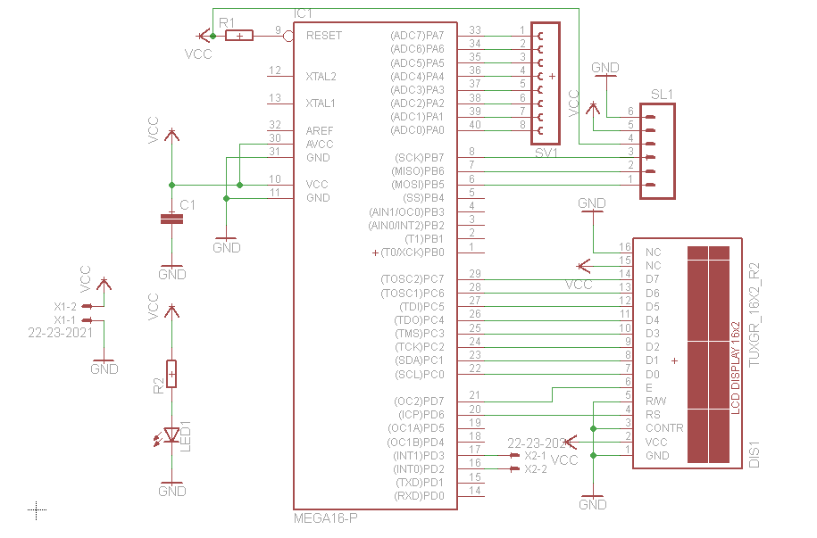

Schematic of Microcontroller (At mega 16) interfaced with (16x2 LCD)

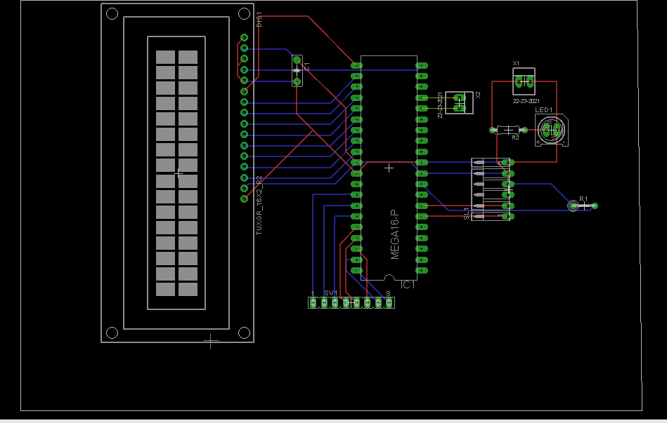
PCB of Microcontroller Interfaced with LCD which includes slots for 4x4 key matrix

Schematic for operational amplifier, comparator, which also includes filter as well as 555 timers (mono-stable multi-vibrator):-

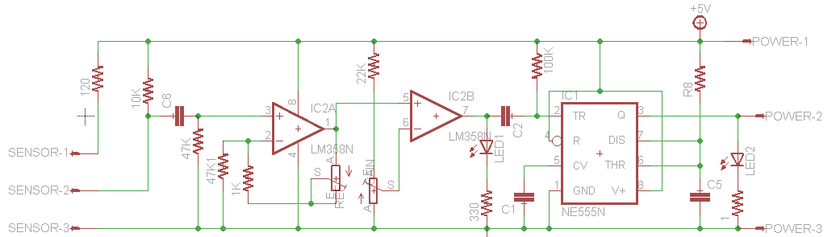

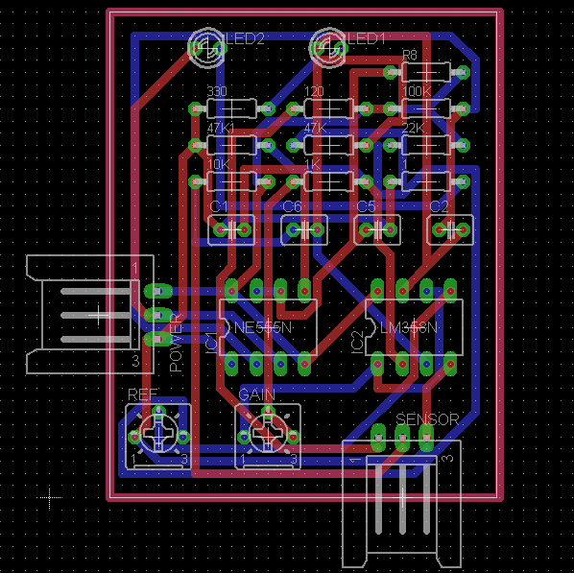
PCB of operational amplifiers and 555 mono-stable multi-vibrator

Circuit Component Description:-
1) Operational Amplifier LM-358:-
The LM358 series consists of two independent, high gain, internally frequency compensated operational amplifiers which were designed specifically to operate from a single power supply over a wide range of voltages. Operation from split power supplies is also possible and the low power supply current drain is independent of the magnitude of the power supply voltage. It eliminates the dual power supply. Allows direct sensing near GND and VOUT also goes to GND .

2)555 timer as Mono-stable Multi-vibrator:-
A mono-stable circuit produces a single output pulse when triggered. It is called a mono-stable because it is stable in just one state: 'output low'. The 'output high' state is temporary.
The duration of the pulse is called the time period (T) and this is determined by resistor R1 and capacitor C1:
time period, T = 1.1 × R1 × C1
T = time period in seconds (s)
R1 = resistance in ohms ()
C1 = capacitance in farads (F)
The timing period is triggered (started) when the trigger input (555 pin 2) is less than ¹/₃ Vs, this makes the output high (+Vs) and the capacitor C1 starts to charge through resistor R1. Once the time period has started further trigger pulses are ignored.
The threshold input (555 pin 6) monitors the voltage across C1 and when this reaches ²/₃ Vs the time period is over and the output becomes low. At the same time discharge (555 pin 7) is connected to 0V, discharging the capacitor ready for the next trigger.
The reset input (555 pin 4) overrides all other inputs and the timing may be cancelled at any time by connecting reset to 0V, this instantly makes the output low and discharges the capacitor. If the reset function is not required the reset pin should be connected to +Vs.

Galvanic Skin Response (GSR)
Galvanic skin response (GSR), also known as electro-dermal response (EDR), psycho-galvanic reflex (PGR), or skin conductance response (SCR), is a method of measuring the electrical resistance of the skin. The device measures electrical resistance between 2 points, and is essentially a type of ohmmeter. The two paths for current are along the surface of the skin and through the body. Active measuring involves sending a small amount of current through the body.
Due to the response of the skin and muscle tissue to external and internal stimuli, the resistance can vary. When correctly calibrated, the GSR can measure these subtle differences. There is a relationship between sympathetic activity and emotional arousal, although one cannot identify the specific emotion being elicited. The GSR is highly sensitive to emotions in some people. Fear, anger, startle response, orienting response and sexual feelings are all among the emotions which may produce similar GSR responses. These reactions have allowed lie detectors to have some success.
Schematic :-

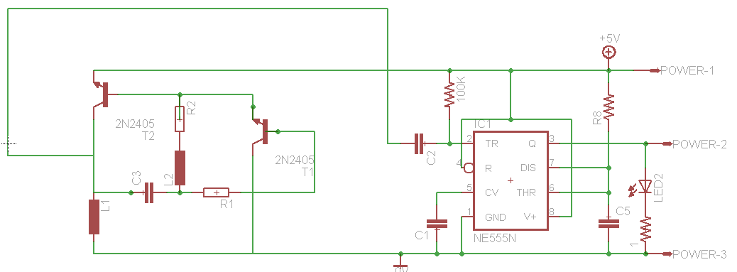
Schematic of GSR connected to 555 mono-stable multi-vibrator
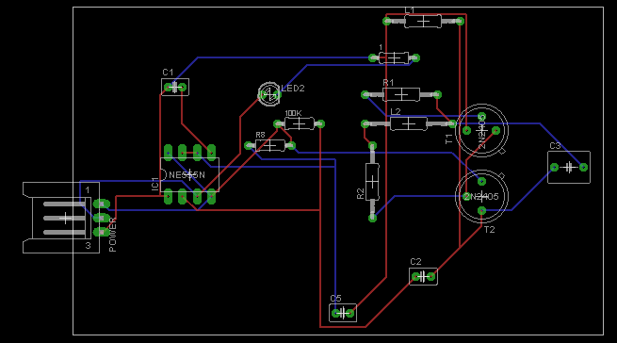
PCB design of GSR and 555 mono-stable multi-vibrator

Observations from GSR Circuit:
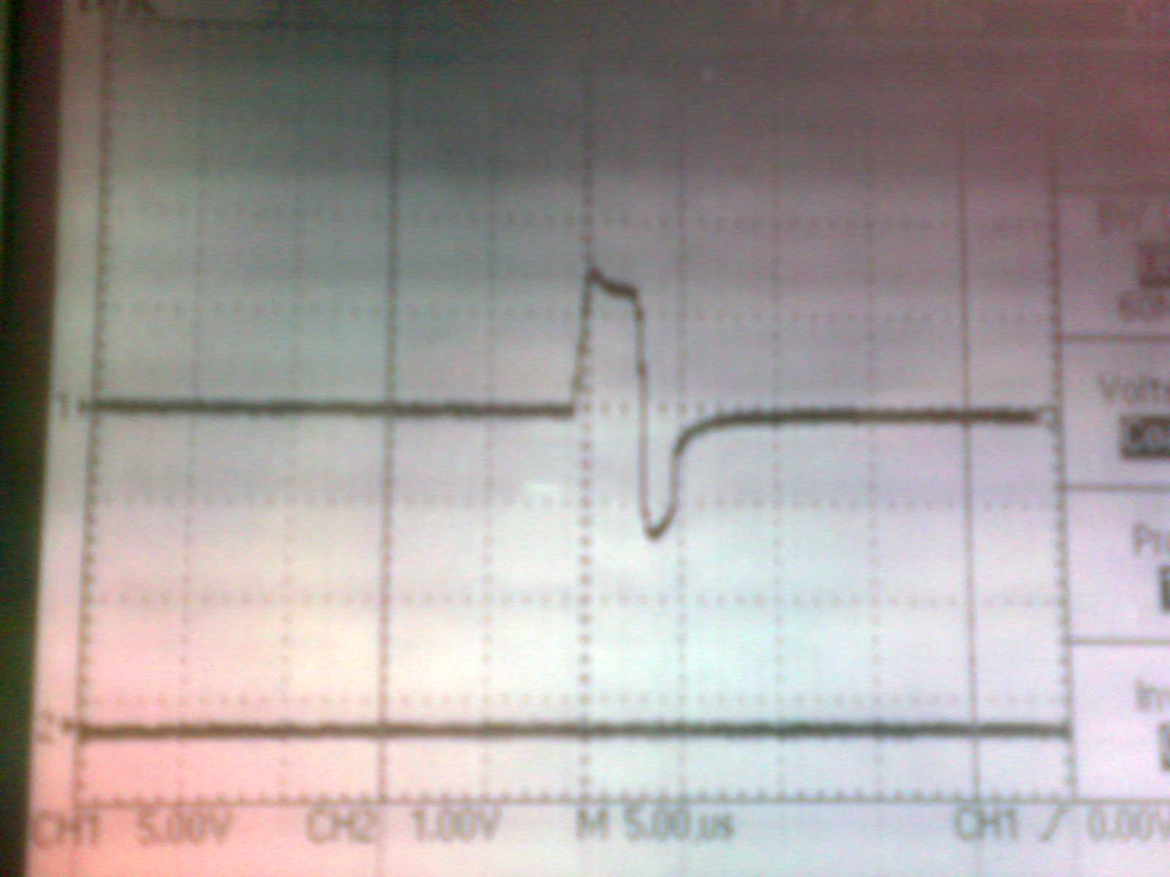
Fig. Result for R=1M Ώ and f = 30.78 Hz
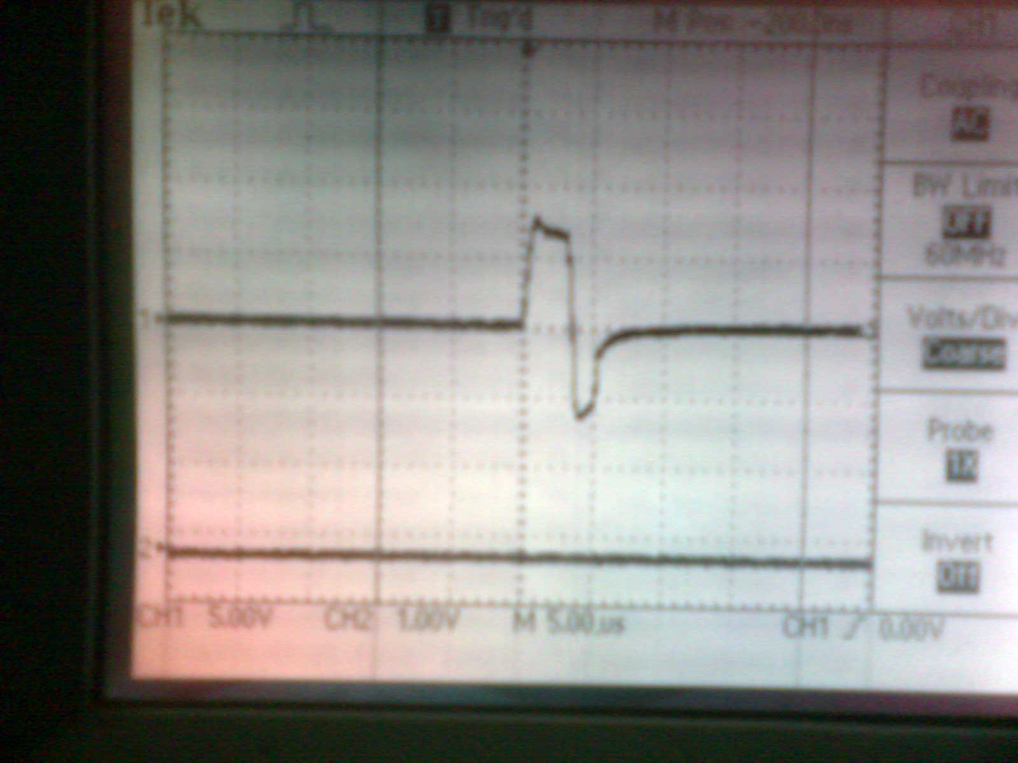
Fig. Result for R=680 k Ώ and f =44.44 Hz

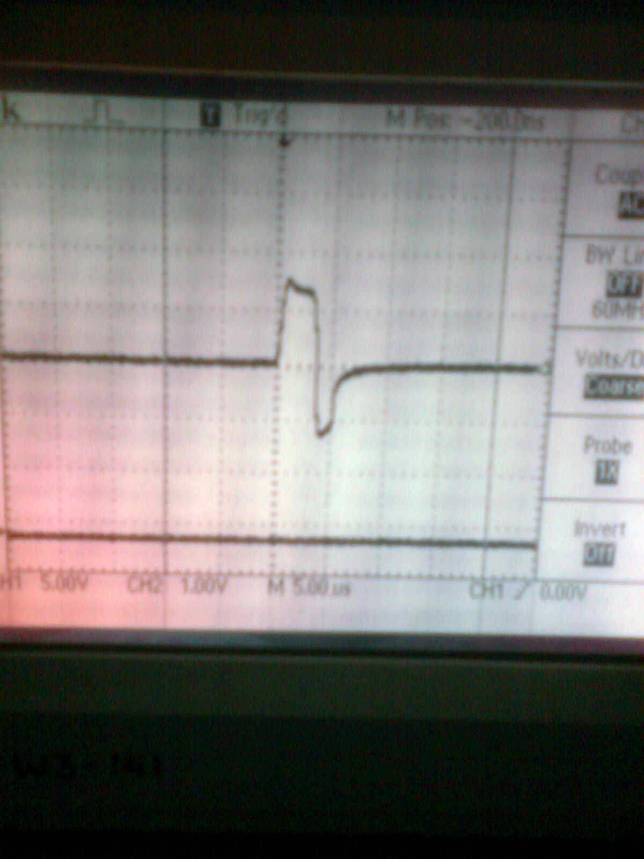
Fig Result for R=820 k Ώ and f =37 Hz
And also for R=100k Ώ, f=222Hz
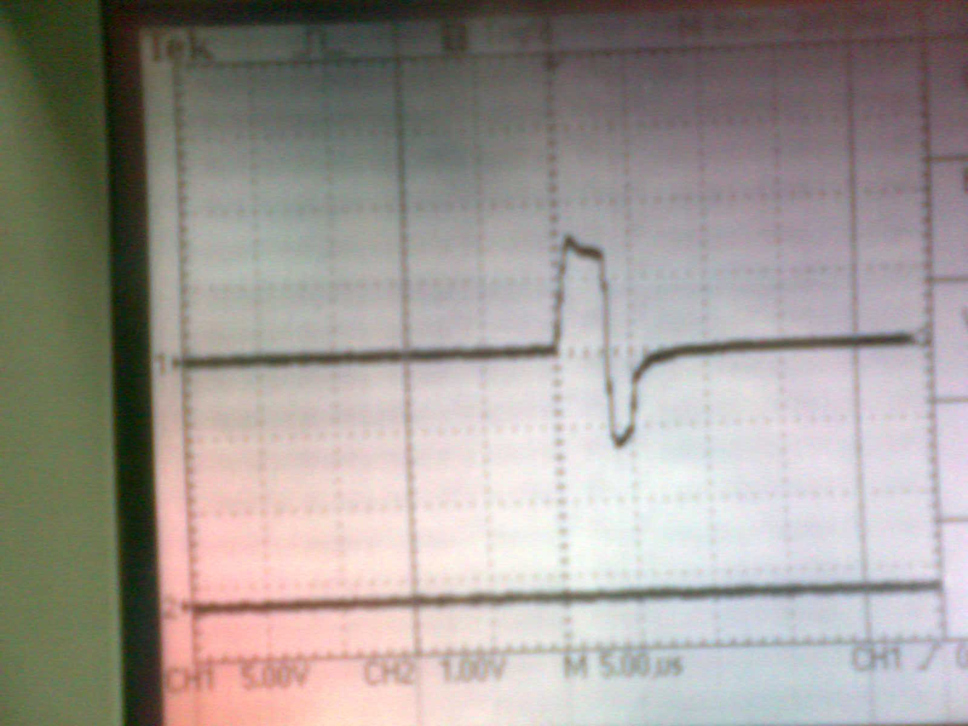
Fig. Result for R=820 Ώ and f =666.67 Hz

Speech Analysis
Our brain is closely monitoring our speaking process, as it is one of the most complex muscular activities the human body can perform. Due to this close supervision, the speech flow might be slowed a little or fasten a little, become more or less intense, and its frequency structure might become scattered or shifted. It's true that in many cases we can control the way we sound, but this is also a part of the brain involvement, trying to produce the "output" as the brain wanted it sound. This brains activity is also reflected in the speech waveform.
By measuring and clustering the unique appearances in the voice we can tell many things, such as the level of "Adrenaline" in the blood (or other natural drugs), how much both parts of the brain agrees between themselves, is there an internal conflict in the brain, does the brain go into Fight-Or-Flight (Stress) mode, did the subject want to tell us what he just did, how concentrated he is and many more.
There are different ways to get a conclusion about a person’s behaviour by studying the speech patterns. There is a history of lie detection instrumentation with the focus on Polygraph and VSA (Voice Stress Analysis) technologies and procedures. Voice stress analysis is based on the principle of Microtremors. It says that as the body reacts there are infrasonic sound signals from muscles that are beyond audible range (roughly 20-20k Hz). Microtremors analysis scans frequencies between 8-12 Hz. Most of the microphones and ALL telephone lines do not transmit or record this frequency range at all. On the other hand we have the polygraphs whose reliability in the hands of professionals is proven. Whereas the polygraph tests are highly controlled and the test procedures standardized, voice stress analysis typically lacks these controls, proving to be a forensic blessing and curse. The blessing is that the voice stress analysis is more cost efficient, less time consuming and has more utility. The curse is that of the accuracy of the procedure to detect deception is quite less than that of the standard polygraph tests. Unlike the polygraph, the voice stress analysis can be done without a person’s permission, without him or her being physically present, and the samples can be taken from commercial television, radio and other audio broadcasts.

A proposed algorithm for spectrum analysis:

The peak in spectrum changes as the signal changes. Though it would not be easy to separate the very lower part of the frequency spectrum containing infrasonic information that can be used for VSA , we can have the analysis for the higher range of the spectrum which can be used in more ways than lower range.

Spectrum

BPF
BPF
BPF
BPF

><T_{h}
><T_{h}

><T_{h}

><T_{h}

Microcontroller

In this scheme the spectrum is split into different frequency bands. The band has a peak in lower range of frequencies which shifts with the change in the signal. The strength in each band is compared with a certain threshold T_{h} which is got by some previous analysis of the signal from same source. Thus the threshold is set such that only one of the spectral bands gives true for comparators which in turn can be checked by a microcontroller.

Spectrum Analysis:

In most practical scenarios the voice input is taken into software and the voice is either recorded to manipulate the different aspects or is just buffered for a real time analysis. Designing hardware for the same is a very tedious task as the accuracy is nowhere good for the lack of even a little amount of precision. By directly using a DSP module we can get the spectrum of any given signal but to have a cheaper design with simpler element is not very useful.
Much different software is available concentrating on one the various aspects of the speech signal. Two of them were used in our project: PRAAT and MATLAB. A recorded signal can be easily processed with the help of PRAAT. Though it doesn’t provide the real time analysis for the signal but the evaluation of certain properties is much easier for a recorded signal. On the other hand MATLAB can be used for the real time analysis of a speech signal. The spectrum of the signal can be observed by an expert who can then decide the behavior of some of the parameters and conclude the result.
Features of Speech Spectrum:
The study of human vocal apparatus has shown that speech is simply the acoustic wave that is radiated from the vocal system when air is expelled from the lung and the resulting flow of air is perturbed by a constriction somewhere in the vocal tract. Since speech signal is time-varying, the analysis should be a time-frequency analysis. Speech can be generally divided into voiced and unvoiced. We studied both the spectrum of typical voiced and unvoiced block. The spectrum in Fig. below shows that for a voiced speech, the time series have obvious periodic. The spectrum of voiced speech is featured as some fine spectrum with formant envelope. The fine peaks mean the pitch period and the formants reflect the vocal tract feature. While for the unvoiced case, the signal looks much like a white noise. The spectra lose the pitch period but keep some formant peaks.
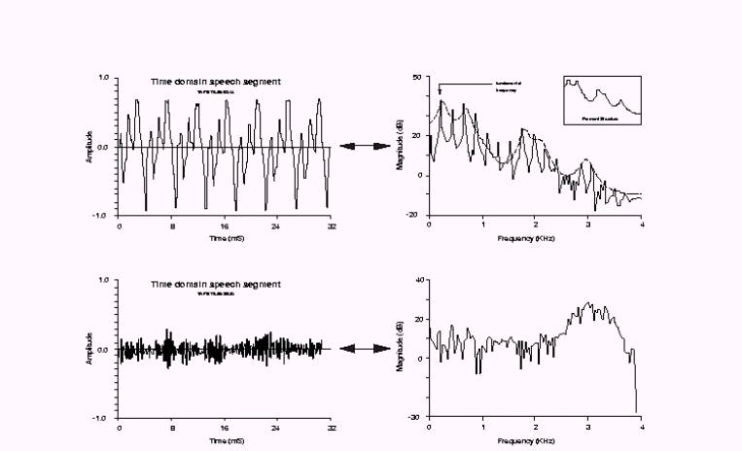
Fig. The upper one shows a typical voiced signal and the lower one an unvoiced one

Real – time speech spectrum:
The code presented for MATLAB takes the input as a speech signal. There are internal software triggers set at some intervals of time. For input signals of above the power of some threshold the signal is taken in a buffer memory for the use afterwards. The analog signal thus collected is sampled with a rate of 8k Hz. The signal thus broken down into many pieces can then equal lengths of the signal can be processed for spectrum analysis. The fast Fourier transform is performed to get the spectrum for these time frames are preformed and the results are shown in graphs. The intake can be made to last for as long as wanted and accordingly the number of graphs will increase. Also a live frequency spectrum view is given. Though the changes are fast one can view some of the characteristics of the spectrum. Both of the data, the live view and the real time analyzed spectrums can than be given to a professional who will make a proper conclusion.

MATLAB Code:

%Create the analog input object AIVoice for a sound card.
AIVoice = analoginput('winsound');
%Add one hardware channel to AIVoice.
chan = addchannel(AIVoice,1);

% Define a 9.0-second total acquisition time and configure a software

duration = 0.5; % One second acquisition for each trigger
set(AIVoice,'SampleRate',8000)
ActualRate = get(AIVoice,'SampleRate');
set(AIVoice,'Timeout',5)
set(AIVoice,'SamplesPerTrigger',ActualRate*duration)
set(AIVoice,'TriggerChannel',chan)
set(AIVoice,'TriggerType','Software')
set(AIVoice,'TriggerCondition','Rising')
set(AIVoice,'TriggerConditionValue',0.2)
set(AIVoice,'TriggerRepeat',17)

%Start AIVoice, acquire the specified number of samples

demoai_fft
start(AIVoice)
wait(AIVoice,duration+17)
[d1,t1] = getdata(AIVoice);
[d2,t2] = getdata(AIVoice);
[d3,t3] = getdata(AIVoice);
[d4,t4] = getdata(AIVoice);
[d5,t5] = getdata(AIVoice);
[d6,t6] = getdata(AIVoice);
[d7,t7] = getdata(AIVoice);
[d8,t8] = getdata(AIVoice);
[d9,t9] = getdata(AIVoice);
[d10,t10] = getdata(AIVoice);
[d11,t11] = getdata(AIVoice);
[d12,t12] = getdata(AIVoice);
[d13,t13] = getdata(AIVoice);
[d14,t14] = getdata(AIVoice);
[d15,t15] = getdata(AIVoice);
[d16,t16] = getdata(AIVoice);
[d17,t17] = getdata(AIVoice);
[d18,t18] = getdata(AIVoice);

%Plot the data for both triggers.

% subplot(411), plot(t1,d1), grid on, hold on
% xlabel('Time (sec.)'), ylabel('Signal level (Volts)'),
% title('Voice Activation First Trigger')
% subplot(412), plot(t2,d2), grid on
% xlabel('Time (sec.)'), ylabel('Signal level (Volts)')
% title('Voice Activation Second Trigger')
% subplot(413), plot(t3,d3), grid on, hold on
% xlabel('Time (sec.)'), ylabel('Signal level (Volts)'),
% title('Voice Activation Third Trigger')
% subplot(414), plot(t4,d4), grid on, hold on
% xlabel('Time (sec.)'), ylabel('Signal level (Volts)'),
% title('Voice Activation Third Trigger')

Fs = 8000; % Sampling frequency
L = 8000; % Length of signal
NFFT = 2^nextpow2(L); % Next power of 2 from length of y
Y1 = fft(d1,NFFT)/L;
Y2 = fft(d2,NFFT)/L;
Y3 = fft(d3,NFFT)/L;
Y4 = fft(d4,NFFT)/L;
Y5 = fft(d5,NFFT)/L;
Y6 = fft(d6,NFFT)/L;
Y7 = fft(d7,NFFT)/L;
Y8 = fft(d8,NFFT)/L;
Y9 = fft(d9,NFFT)/L;
Y10 = fft(d10,NFFT)/L;
Y11 = fft(d11,NFFT)/L;
Y12 = fft(d12,NFFT)/L;
Y13 = fft(d13,NFFT)/L;
Y14 = fft(d14,NFFT)/L;
Y15 = fft(d15,NFFT)/L;
Y16 = fft(d15,NFFT)/L;
Y17 = fft(d15,NFFT)/L;
Y18 = fft(d15,NFFT)/L;

f = Fs/2*linspace(0,1,NFFT/1.4);

% Plot single-sided amplitude spectrum.
figure
subplot(311),plot(f,2*abs(Y1(1:NFFT/1.4))), grid on, hold on
title('Single-Sided Amplitude Spectrum of y(t)')
xlabel('Frequency (Hz)')
ylabel('|Y1(f)|')
subplot(312),plot(f,2*abs(Y2(1:NFFT/1.4))), grid on, hold on
xlabel('Frequency (Hz)')
ylabel('|Y2(f)|')
subplot(313),plot(f,2*abs(Y3(1:NFFT/1.4))), grid on, hold on
xlabel('Frequency (Hz)')
ylabel('|Y3(f)|')

figure
subplot(311),plot(f,2*abs(Y4(1:NFFT/1.4))), grid on, hold on
title('Single-Sided Amplitude Spectrum of y(t)')
xlabel('Frequency (Hz)')
ylabel('|Y4(f)|')
subplot(312),plot(f,2*abs(Y5(1:NFFT/1.4))), grid on, hold on
xlabel('Frequency (Hz)')
ylabel('|Y5(f)|')
subplot(313),plot(f,2*abs(Y6(1:NFFT/1.4))), grid on, hold on
xlabel('Frequency (Hz)')
ylabel('|Y6(f)|')

figure
subplot(311),plot(f,2*abs(Y7(1:NFFT/1.4))), grid on, hold on
title('Single-Sided Amplitude Spectrum of y(t)')
xlabel('Frequency (Hz)')
ylabel('|Y7(f)|')
subplot(312),plot(f,2*abs(Y8(1:NFFT/1.4))), grid on, hold on
xlabel('Frequency (Hz)')
ylabel('|Y8(f)|')
subplot(313),plot(f,2*abs(Y9(1:NFFT/1.4))), grid on, hold on
xlabel('Frequency (Hz)')
ylabel('|Y9(f)|')

figure
subplot(311),plot(f,2*abs(Y10(1:NFFT/1.4))), grid on, hold on
title('Single-Sided Amplitude Spectrum of y(t)')
xlabel('Frequency (Hz)')
ylabel('|Y10(f)|')
subplot(312),plot(f,2*abs(Y11(1:NFFT/1.4))), grid on, hold on
xlabel('Frequency (Hz)')
ylabel('|Y11(f)|')
subplot(313),plot(f,2*abs(Y12(1:NFFT/1.4))), grid on, hold on
xlabel('Frequency (Hz)')
ylabel('|Y12(f)|')

figure
subplot(311),plot(f,2*abs(Y13(1:NFFT/1.4))), grid on, hold on
title('Single-Sided Amplitude Spectrum of y(t)')
xlabel('Frequency (Hz)')
ylabel('|Y13(f)|')
subplot(312),plot(f,2*abs(Y14(1:NFFT/1.4))), grid on, hold on
xlabel('Frequency (Hz)')
ylabel('|Y14(f)|')
subplot(313),plot(f,2*abs(Y15(1:NFFT/1.4))), grid on, hold on
xlabel('Frequency (Hz)')
ylabel('|Y15(f)|')

figure
subplot(311),plot(f,2*abs(Y16(1:NFFT/1.4))), grid on, hold on
title('Single-Sided Amplitude Spectrum of y(t)')
xlabel('Frequency (Hz)')
ylabel('|Y16(f)|')
subplot(312),plot(f,2*abs(Y17(1:NFFT/1.4))), grid on, hold on
xlabel('Frequency (Hz)')
ylabel('|Y17(f)|')
subplot(313),plot(f,2*abs(Y18(1:NFFT/1.4))), grid on, hold on
xlabel('Frequency (Hz)')
ylabel('|Y18(f)|')

Code for ATMEGA16 interfaced with 16x2 LCD and 4x4 keypad:

#include<avr/io.h>
#include "lcdroutines.h"
#include<util/delay.h>
#include<avr/interrupt.h>
#define MIN 58594L
#define SEC 976

unsigned char countL = 0;
unsigned int countK = 0;
unsigned char timecount = 0;
char display = 0;
char lcdBusy = 0;
char upper = 10; //Change value later
char upperCount = 0;
unsigned char beat[100] = {0};
unsigned int gsr[100] = {0};
unsigned char a[] = {"Beat : "};
unsigned char b[] = {"GSR : "};
unsigned char c[] = {"Display Mode"};
unsigned char d[] = {"Count Mode"};
unsigned char e[] = {"Enter Time"};
unsigned char f[] = {" "};
unsigned char g[] = {" "};
unsigned char time = 0;
ISR(INT0_vect){
++countL;
}
ISR(INT1_vect){
++countK;
}
void displayData(void){
lcd_clear();
for(unsigned char i =0;i<sizeof(a)-1;i++) display_char(a[i]);
display_byte(countL);
for(unsigned char i =0;i<sizeof(g)-1;i++) display_char(g[i]);
display_byte(timecount);
move_to(0,1);
for(unsigned char i =0;i<sizeof(b)-1;i++) display_char(b[i]);
display_int(countK);
}
ISR(TIMER1_COMPA_vect ){
PORTB ^= _BV(PB0);
if(!lcdBusy) displayData();
beat[timecount] = countL;
gsr[timecount] = countK;
++upperCount;
if(upper == upperCount){
++timecount;
countL = 0;
countK = 0;
upperCount = 0;
}
}
void displayOldData(char time){
lcd_clear();
for(unsigned char i =0;i<sizeof(a)-1;i++) display_char(a[i]);
display_byte(beat[time]);
for(unsigned char i =0;i<sizeof(g)-1;i++) display_char(g[i]);
display_byte(timecount);
move_to(0,1);
for(unsigned char i =0;i<sizeof(b)-1;i++) display_char(b[i]);
display_int(gsr[time]);
}
void displayDM(void){
lcd_clear();
for(unsigned char i =0;i<sizeof(c)-1;i++) display_char(c[i]);
_delay_ms(1000);
}
void displayCM(void){
lcd_clear();
for(unsigned char i =0;i<sizeof(d)-1;i++) display_char(d[i]);
_delay_ms(1000);
}
void processKey(char currKey){
if(currKey == 'c' || currKey == 'd' || currKey == 'e' || currKey == 'f' || currKey == 'g'){}
else if(currKey == 'a'){
time /= 10;
move_to(0,1);
for(unsigned char i =0;i<sizeof(f)-1;i++) display_char(f[i]);
move_to(0,1);
display_byte(time);
}
else{
time *= 10;
time += (currKey - '0');
move_to(0,1);
for(unsigned char i =0;i<sizeof(f)-1;i++) display_char(f[i]);
move_to(0,1);
display_byte(time);
}
_delay_ms(100);
};
char getKey(void){
char key = 'g';
PORTA = 0xfe;
if(((PINA & 0x3c) >> 2) == 0x07)key = '0';
else if(((PINA & 0x3c) >> 2)==0x0b)key = 'd';
else if(((PINA & 0x3c) >> 2)==0x0d)key = 'e';
else if(((PINA & 0x3c) >> 2)==0x0e)key = 'f';
//if(key!=-1) return key;
PORTA = 0xfd;
if(((PINA & 0x3c) >> 2) == 0x07)key = 'c';
else if(((PINA & 0x3c) >> 2)==0x0b)key = '9';
else if(((PINA & 0x3c) >> 2)==0x0d)key = 'a';
else if(((PINA & 0x3c) >> 2)==0x0e)key = 'b';
//if(key!=-1) return key;
PORTA = 0xbf;
if(((PINA & 0x3c) >> 2) == 0x07)key = '8';
else if(((PINA & 0x3c) >> 2)==0x0b)key = '5';
else if(((PINA & 0x3c) >> 2)==0x0d)key = '6';
else if(((PINA & 0x3c) >> 2)==0x0e)key = '7';
//if(key!=-1) return key
PORTA = 0x7f;
if(((PINA & 0x3c) >> 2) == 0x07)key = '4';
else if(((PINA & 0x3c) >> 2)==0x0b)key = '1';
else if(((PINA & 0x3c) >> 2)==0x0d)key = '2';
else if(((PINA & 0x3c) >> 2)==0x0e)key = '3';
//if(key!=-1) return key;
/*
0 d e f c 9 a b 8 5 6 7 4 1 2 3
*/
return key;
}
int main(void){
DDRA = 0xc3;
PORTC = 0x3c;
DDRB |= _BV(PB3) | _BV(PB0) | _BV(PB1); //Set PB3 for output
TCCR0 = _BV(COM00) | _BV(CS02) | _BV(CS00); //Set prescaler and enable toggling of OCR pin. (Refer datasheet for details)
TCCR1B = _BV(WGM12) | _BV(CS10) | _BV(CS12);
TIMSK = _BV(OCIE1A);
OCR1A = SEC;
MCUCR = _BV(ISC01) | _BV(ISC00) | _BV(ISC11) | _BV(ISC10);
GICR = _BV(INT0)| _BV(INT1);
sei();
_delay_ms(1000);
lcd_init();
while(1){
if(getKey() == 'c'){
lcdBusy = 1;
PORTB ^= _BV(PB0);
displayDM();
char tempKey = getKey();
while(tempKey != 'b'){
processKey(tempKey);
tempKey = getKey();
}
displayOldData(time);
time = 0;
}
else if(getKey() == 'd'){
displayCM();
displayData();
lcdBusy = 0;
}
};
return 0;
}

Acknowledgements:
Special thanks to Mr. N. M. Adiwarekar for all his help.

References:
- S. Edwards., “Heart rate Monitor Book”, Leisure systems international, Dec. 1993.
- M. Malik and A. J. Camm., “Heart Rate Variability”, Futura Publishing Co. Inc., sept. 1995.
- J. R. Hampton., “The ECG In Practice”., Churchill Livingstone., Mar. 2003.
- A. R. Houghton and D. Gray., “making sense of the ECG”., Hodder Arnold Publishing 2003.
- Forerunner 201/301 User Guide, web site: http://www.grmin.com
- Pulsar heart rate monitors, web site: http://www.heartratemonitor.co.uk
- http://www.jstor.org/stable/3625011?seq=1
- http://www.owlnet.rice.edu/~elec532/PROJECTS00/vocode/spectral.html
- Website: How stuff works
- Website: Matlab Central
- Wikipedia

