**VALIDATION FOR A SINGLE TRAIN CASE**

Consider a line from station A to station B. The network layout is shown below:-

Station B: start: 10km, end: 11km

Station A: start: 0km, end: 1km

Let us consider a single train with the following parameters:

Acceleration and Deceleration: 0.1 m/s2

Length: 500 m

Maximum Allowable Speed: 60 km/hr=16.67 m/s

Running the simulator gives the (average) traveling time to be 12.77 minutes. We verify the details below. Consider the traveling time to be the time taken by the train to start from station A and it finally coming to a stop in station B.

If the train starts with zero initial velocity, the time it takes to reach 16.67 m/s with the given acceleration is given by

$$v-u=at v:final velocity, u:initial velocity, a:acceleration$$

$$t=\frac{16.67}{0.1}=166.67 s$$

So in this time the train must have gone some distance, which we calculate by

$$v^{2}-u^{2}=2aS where S is the required distance$$

$$S=\frac{v^{2}}{2a}=\frac{{16.67}^{2}}{2*0.1}=1389.44 m$$

So, when the train reaches its full speed it has already covered a distance of (1389.44+500) m from the start of station A. It has to decelerate at an appropriate time for coming to stop at station B. It has to stop at 10,500m. However it has a stopping distance of 1389.44 m. Hence it must start decelerating from (10500-1389.44) m. So we can say that it travels at a speed of 16.67 m/s from 1889.44 m to 9110.56 m. The time taken by the train to cover this distance is

$$\frac{9110.56-1889.44}{16.67}=433.18 s$$

So, the total time that it takes traveling from A to B is

$$\frac{433.18+166.67+166.67}{60}=12.77 mins$$

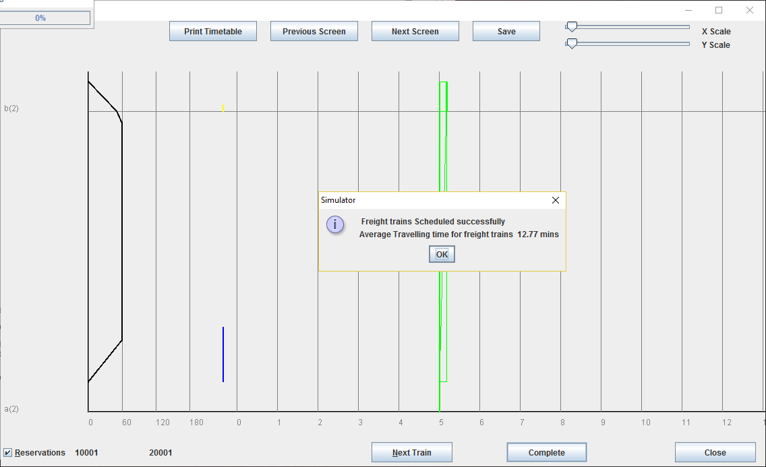

Fig 1: Screen shot of the simulator after running the above test case

**VALIDATION FOR A MULTI-TRAIN CASE**

Let us now consider a case with two trains-one scheduled and one unscheduled in our system. Consider that the scheduled train receives a higher priority. We consider three stations with each station length being 1km. Both the trains have a length of 500m. The scheduled train has the following specifications:-

Acceleration and Deceleration: 0.5m/s2

Maximum Speed: 130 km/hr=81.25 m/s

The freight train has the following specifications:

Acceleration and Deceleration: 0.1m/s2

Maximum Speed: 60 km/hr=16.67 m/s

Station A: start: 0km, end: 1km

Station C: start: 20km, end: 21km

Station B: start: 10km, end: 11km

The timetable generated by the Simulator is shown in simplified terms:

|  |  |  |  |  |  |  |
| --- | --- | --- | --- | --- | --- | --- |
| **TRAIN TYPE** | **STATION A :ARR** | **STATION A: DEP** | **STATION B: ARR** | **STATION B:DEP** | **STATION C:ARR** | **STATION C:DEP** |
| *Scheduled Train* | 05:13 | 05:14 | 05:27:14 | 05:28:09 | 05:37:49 | 05:44:17 |
| *Unscheduled Train* | 04:50 | 04:50 | 05:04:25 | 05:39:32 | 05:54:16 | 05:56:44 |

Now we analyze the generated time-table for any violation of safety norms.

Station B is a station where there are no stops for the scheduled train. For consistency in calculations both arrival and departure of trains have been considered with respect to the tail of the train.

The unscheduled train in this case goes from station A to station B thereby reserving the block between these two stations up to 05:04:25. However the scheduled train arrives at station A only at 05:13 and the unscheduled train is thus allowed to move to station B. Now the simulator calculates that the unscheduled train would make the scheduled train wait at station B if the unscheduled train is allowed to leave station B. This is because the block between Station B and C would then be reserved by the unscheduled train. So, it gives a higher priority to the scheduled train and makes the unscheduled train wait at station B, where it is overtaken by the scheduled train. Thus overtaking takes place at station B. This is shown circled in red in the screenshot of the simulator output that follows. Thus safety norms are adhered to.

All the traversal times can be checked to be in accordance with the laws of motion as in the previous example. Thus the simulator output for the multiple train case is verified.

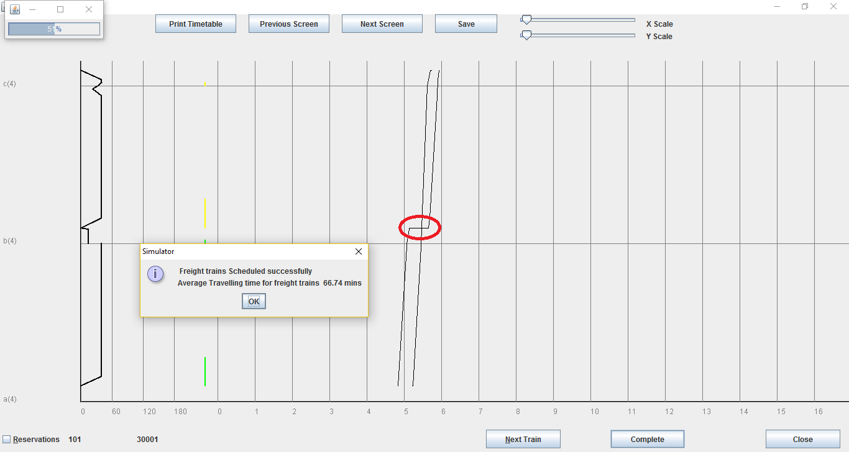

Fig 2: Screenshot of the simulator after running the second test case

Cases where there are more than two trains and they have different priorities can also be run using the simulator. The working of simulator can be verified in a similar fashion as has been shown in this document.

For updates about the Simulator and code documentation visit: <https://www.ee.iitb.ac.in/~belur/railways/>