A Cluster-based Target-driven Illumination Correction

Scheme for Aerial Images

Ameya Galinde, Subhasis Chaudhuri
Department of Electrical Engineering, IIT, Powai, Mumbai-400076
&
Jharna Majumdar
Aeronautical Development Establishment, DRDO, Bangalore-560093

Abstract

Aerial images obtained by UAVs suffer from drastic variations in image quality due to large variations in atmospheric and ambient illumination conditions. For a proper interpretation of the scene, a good quality of the image is required. We propose a feed-forward neural network based color look-up table re-mapping scheme under which each gray level is mapped to a different value for contrast enhancement. In order to train the network, we use one of the good quality images obtained during one of the earlier missions. The image is segmented through a fuzzy C-means clustering technique, and the histograms of each region are mapped to those in the training image. We show that a very good enhancement can be obtained using the proposed scheme.

Index terms - fuzzy c-means clustering, image segmentation, feed forward neural network, contrast restoration, illumination correction, weather-degraded images.

1. Introduction

The problem of varying lighting condition is one of the major problems that affects any computer vision algorithm like target detection or pattern recognition. Efforts have been made to tackle this problem and nullify the effect of ambient illumination conditions or atmospheric and weather conditions. This pre-processing helps in keeping the subsequent pattern recognition stages invariant to any such deviations.

Due to bad weather conditions, the main property of the image that gets severely affected is its contrast. The restoration of contrast is one of the main technique by which the illumination of a scene can appear to have been corrected. True illumination correction in the context of computer vision, should take into account the direction of light sources, their nature – diffuse or specular, the reflectivity of the materials in the scene etc. A very good attempt at a physics based model for correcting weather-degraded images is given in [1]. But, usually such techniques require a huge amount of processing power, which is not feasible for developing real-time systems. Hence we resort to the technique of contrast restoration that very well resembles illumination correction, at least for gray scale images. In this paper, we shall concentrate only on gray scale images. Also, we shall mainly be working on aerial images taken by unmanned air vehicles or UAV [2][3].

When we talk of correcting the contrast, we should have a reference image that serves as the canonical image, which has the desired illumination and lighting conditions. This target-driven approach is essential when dealing with situations where in varying degrees of illumination correction are required, mainly due to personal taste or changing standards. Thus we shall consider a pair of aerial images. The image in Figure 1 is the canonical image, whereas the image in Figure 2 is the poorly illuminated image. It is desired to restore the illumination of the image in Figure 2 to that of the image in Figure 1. Note that Figures 1 and 2 are not a matched pair, but they relate to a similar terrain or region. Hence, there is no need for scene correspondence.

Primarily, the techniques used can be thought of as whole-image techniques or region-based techniques. The former comprise of simple image processing methods like – histogram equalization, histogram matching and contrast stretching. These can lead to some local regions of the image not getting optimally stretched. Hence, we have the region-based techniques like - region-wise histogram matching and region-wise contrast stretching. Here, similar regions like - vegetation, water body, rocky regions, grasslands, buildings, roads etc are first identified in the two images – canonical and the bad. This automatic clustering is the reason why such techniques are also called cluster-based techniques. Now, we can either do histogram matching of individual regions in the two images or we can perform region-wise contrast stretching. A major problem with the region-wise techniques is that, the boundary between two adjacent regions shows up. Our technique builds upon the region-wise contrast stretching technique with the main aim to tackle this boundary problem. There are other advantages also, that we shall discuss.

One of the efforts at illumination correction for color images was to remove the effect of ambient lightning conditions in a hand gesture recognition algorithm [4]. The algorithm uses a large set of registered images under varying lighting conditions, to train a feed forward neural network pixel-by-pixel, so that an color map can be generated that restores the constancy to the hand color in skin color space. This idea has been the motivation behind our proposed technique but with some major differences. In their case, the same neural network can be used on bad images with any type of illumination degradation, to restore it to the canonical. However, it requires a point-to-point correspondence between the images. In our case, we are using the same neural network only for correcting bad images with the same type of illumination degradation, and containing any type of geographical region. Also, the images need not be registered, as in Figures 1 and 2. Our technique first consists of segmenting the image and then generating an gray scale map for all the regions using a single neural network. The main steps involved are described in detail next.

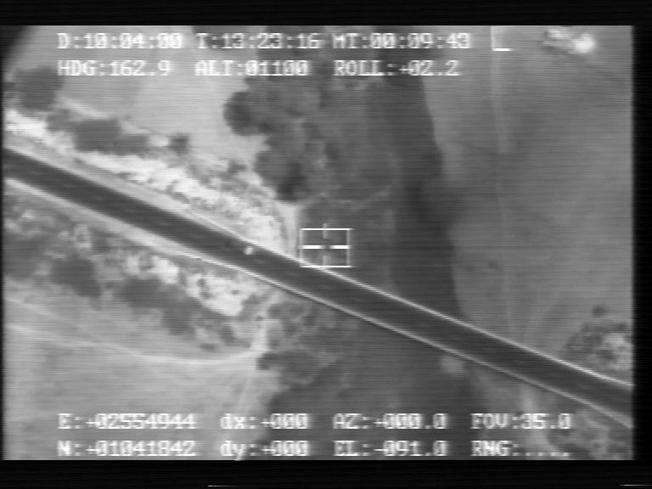

Figure 1. An aerial image with the desired ambient illumination conditions.

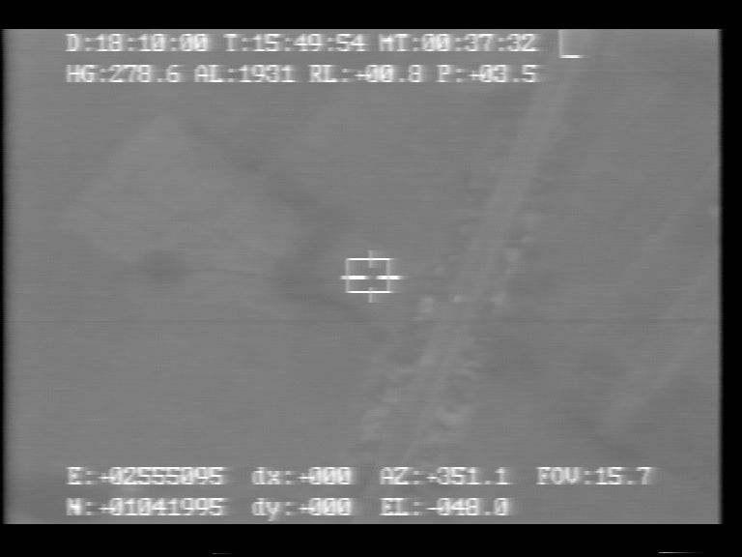

Figure 2. An aerial image that has been degraded due to poor weather conditions.

2. Fuzzy C-means Clustering

For aerial images, the regions are distinguished based on the land form they represent, like - vegetation, water body, rocky regions, grasslands, buildings, roads etc. In terms of image processing features, for gray scale images, this means – gray levels, texture, histograms, entropy etc. A pre-processing step is required, in which we have to use a mask image to avoid the outliers due to title lines or camera target boxes. A mask image is shown in Figure 3. Next, for the purpose of generating feature vectors, the canonical image is divided into blocks of around 15 by 15 pixels and the following features are calculated for each block –

- Average gray level of the block.
- Entropy of the histogram of the block.
- Entropy of the Co-occurrence matrix of the block.

The normalized values for these features, for the image in Figure 1, are shown in Figures 4, 5 and 6, respectively. Features 2 and 3 are texture descriptors. Next we use the fuzzy c-means algorithm to automatically cluster the 3D feature vectors obtained from each block of the canonical image. Here the number of clusters or the number of expected regions is to be specified. After clustering and assigning the region to each block, we get the segmented canonical image, divided into 4 regions, as shown in Figure 7. Next, we calculate the block feature vectors of the poorly illuminated image and identify its regions that correspond to the regions of the canonical image. The image of Figure 2 segmented into similar 4 regions is shown in Figure 8.

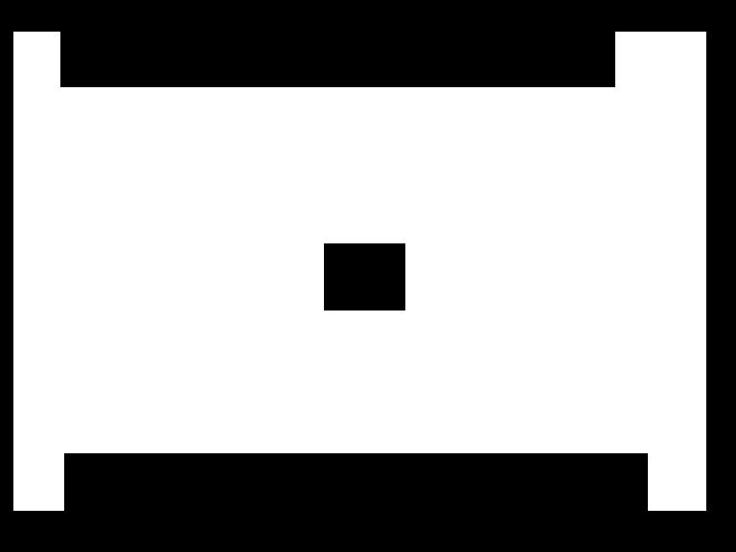

Figure 3. The image mask that is used to keep out the title lines and camera target box, as a pre-processing step.

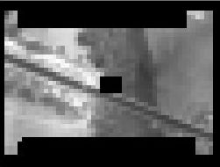

Figure 4. Average gray level of the blocks for the image in Figure 1.

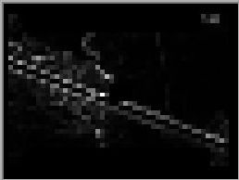

Figure 5. Entropy of the histogram of the blocks for the image in Figure 1.

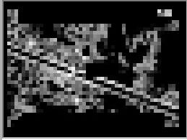

Figure 6. Entropy of the Co-occurrence matrix of the blocks for the image in Figure 1.

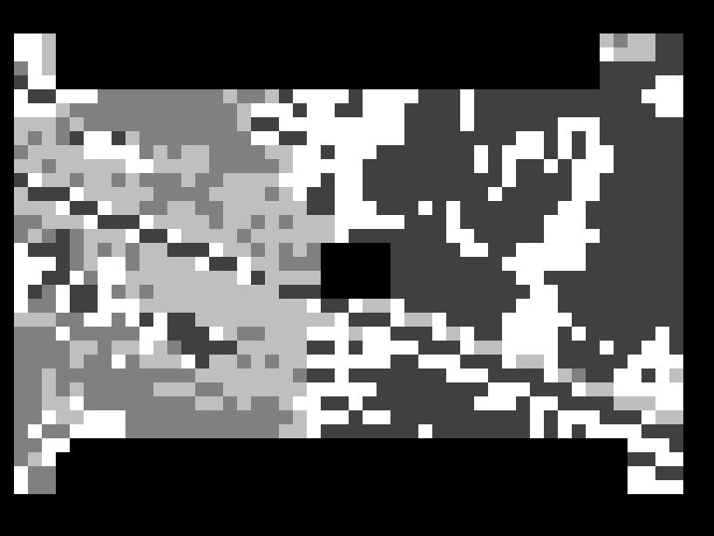

Figure 7. Segmented canonical image of Figure 1 divided into 4 regions.

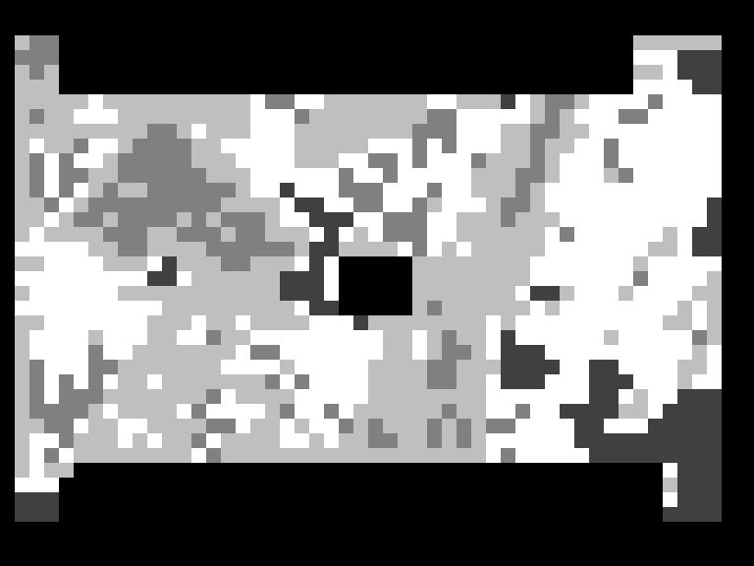

Figure 8. Segmented test image of Figure 2 divided into 4 regions that correspond to the regions in Figure 7.

3. Neural Network Learning and the Re-mapping Table

The linear functions that represent the mapping of the gray levels of individual regions are found out. These mappings serve as the training samples for the neural network. The network used is a simple feed forward neural network with a single hidden layer and one input and output node, as illustrated in Figure 9.

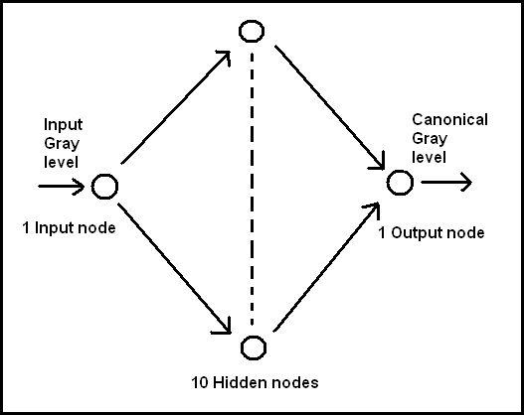

Figure 9. Structure of the feed forward neural network employed.

The learning algorithm employed is the back propagation algorithm. The decrease in the square error at the output layer as training proceeds is shown in Figure 10. Since, the training samples lie on intersecting line segments, the square error will not become zero, but will stabilize. For the kind of UAV images we are using, the number of iterations required for error stabilization is 200000 and the time taken on a P4 1.7 GHz machine, is about 30 seconds.

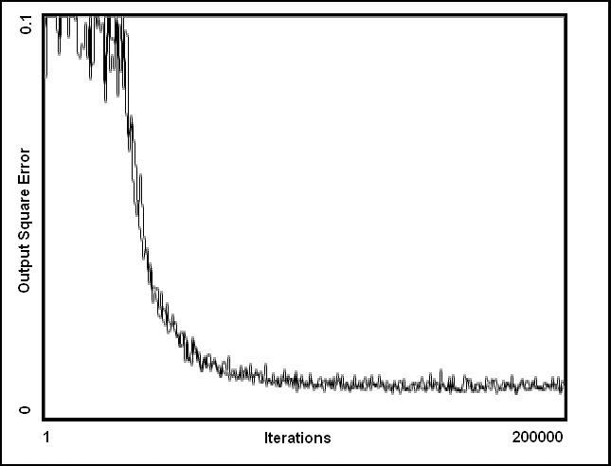

Figure 10. Decrease in the square error at the output layer as training proceeds.

The neural network can also be viewed as a single non-linear R1 to R1 approximating function to the linear maps for the gray levels of all the regions. This function or Input Output map or a plot of the ‘Re-mapping Table’ is depicted in Figure 11.

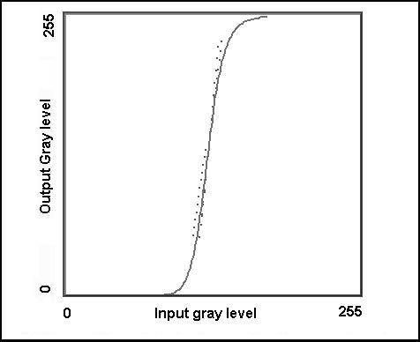

Figure 11. Input Output map of the neural network after training. The dots are the training samples.

4. Results

After training, the neural network is just applied to each pixel of the poorly illuminated image in Figure 2 and the output of the neural network is the contrast-enhanced image with the desired illumination that is similar to that of the canonical image. The final output is shown in Figure 12. The main advantage of our technique is that once the neural network has been trained, it doesn’t have to be retrained when correcting a set of similarly weather-degraded images. This is useful in real-time application like correcting a video sequence streaming from a UAV. Figure 13 shows a similarly weather-degraded image. On applying the same network used for obtaining the image in Figure 12, we get the enhanced version for the image in Figure 13 as shown in Figure 14.

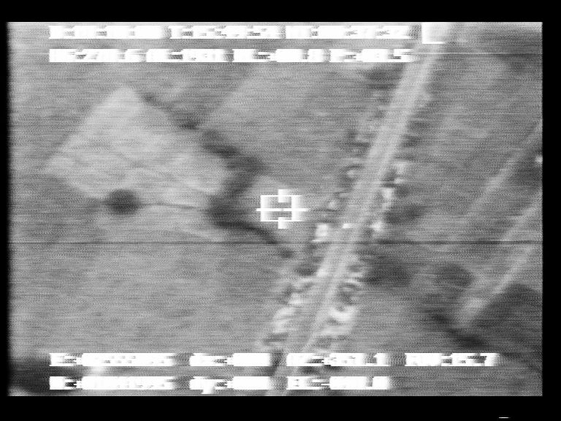

Figure 12. The result of applying the NN-based region-wise contrast-stretching algorithm in the poorly illuminated image in Figure 2. Note that the boundaries visible in Figure 19 are removed.

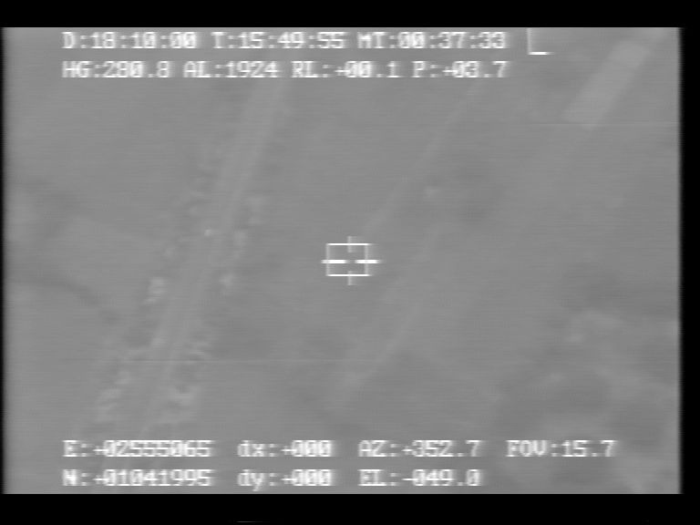

Figure 13. A weather-degraded image with degradation similar to that of the image in Figure 2.

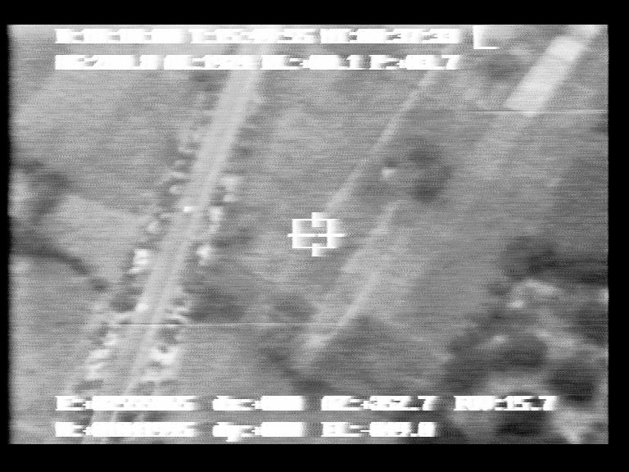

Figure 14. The image of Figure 13 after illumination correction, using the same neural network used for generating the image of Figure 12 from the image in Figure 2, without retraining.

We also present the results with various other techniques for comparison with our results. The result of histogram equalization of the bad image is shown in Figure 15. Histogram matching of the bad image with the canonical image gives the result in Figure 16. Simple contrast stretching yields the result in Figure 17. Region-wise histogram matching, that was described in the introduction sections gives the image in Figure 18. As also, the result of region-wise contrast stretching is shown in Figure 19. (Note that in Figures 18 and 19, the black box and the black strip have been generated due to the use of a mask image in the pre-processing step.)

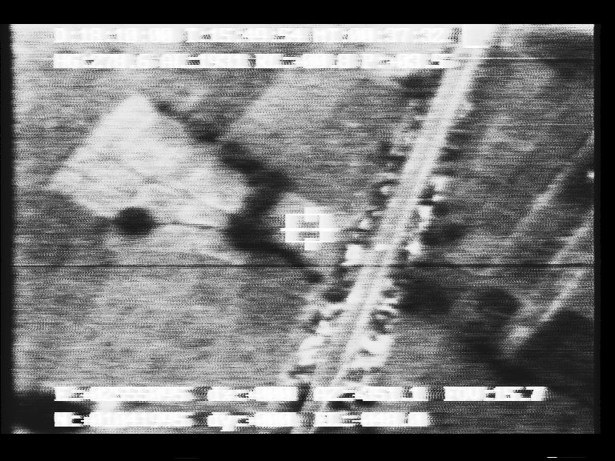

Figure 15. The result of applying histogram equalization on the image in Figure 2.

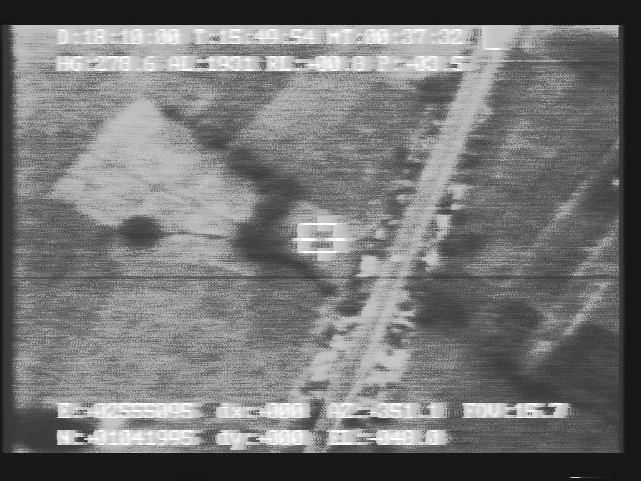

Figure 16. The result of matching the histogram of the image in Figure 2 to that of the image in Figure 1.

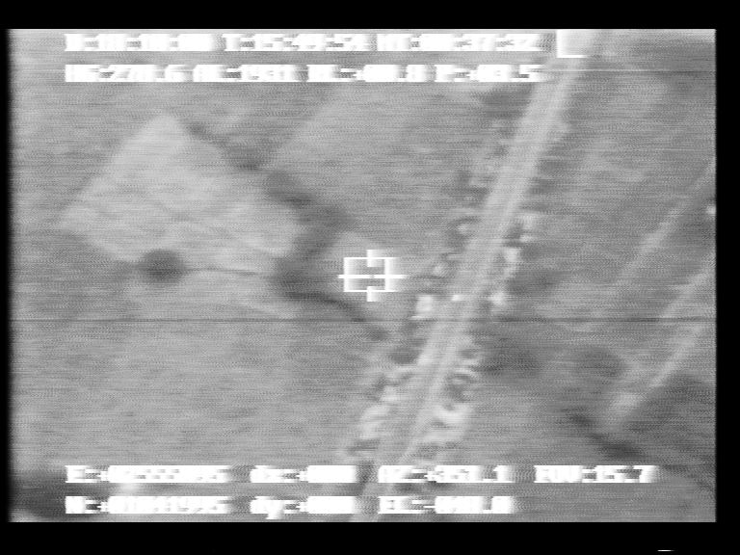

Figure 17. The result of contrast stretching on the image in Figure 2.

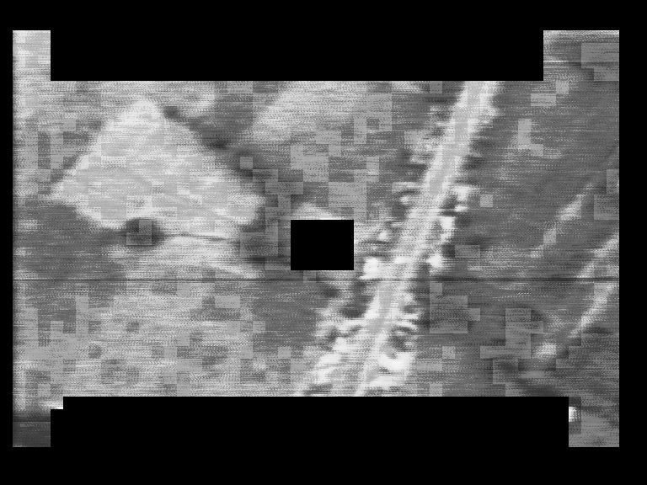

Figure 18. The result of region-wise histogram matching of the image in Figure 2 to that of the image in Figure 1.

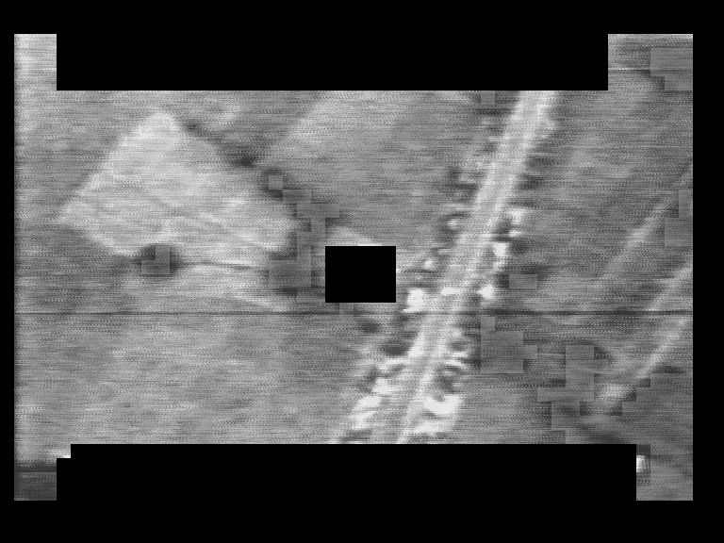

Figure 19. Result of region-wise contrast stretching of the image in Figure 2 to that of the image in Figure 1.

5. Discussion

We had pointed out that our technique aims to tackle the boundary problem that affects region-based techniques. Let us see how. The neural network used, has an approximation capability that has the effect of erasing the region boundaries and smoothing out the transition from one region to another while maintaining the advantage of local contrast enhancement of a region-based technique.

Another point worth noting, regarding the input-output mapping function, is that it is monotonous. This ensures that the gray scale mapping is not many-to-one. Also, it ensures that at the end points, the graph does not flatten and the gray levels do not clipped which can cause smudging of the image, visible especially at the brighter regions.

As mentioned earlier, the main advantage of our technique is that, once the network is trained, it does not have to be retrained. Note that this advantage comes only when dealing with images having similar weather-degradation. We are mainly restricted by the non-availability of registered images and the constraint of working in a 1-D gray color space. Hence, we cannot use the original technique used in [4] and will have to train a different neural network for correcting a different kind of illumination degradation. But it is still worthwhile to note that, on a particular mission of the UAV, the weather degradation is expected to be nearly the same, thus a network will have to be trained only once with one representative sample during the mission and can be used for the entire mission. But for a different mission, the network will have to be retrained. An alternative is to first histogram match the new bad image with the original bad image and then apply the same network.

6. References

[1] S. G. Narasimhan and Shree K. Nayar, “Contrast Restoration of Weather Degraded Images”, IEEE Pattern Analysis and Machine Intelligence, Vol. 25, No. 6, June 2003.

[2] J. Majumdar, “Aerial Image Exploitation for UAV”, paper presented at AERO INDIA 2001, Banglore.

[3] Information about the Indian Air Force UAV - Nishant - http://www.bharat-rakshak.com/LAND-FORCES/Army/Images-UAV.html

[4] A. Nayak & S. Chaudhuri, “Self-Induced Color Correction for Skin Tracking Under Varying Illumination”, ICIP 2003 Proceedings, Vol.2, pages 1009-1012.

